Explanation of the difference between the flow-based plain and flow-based intuitive market coupling approach

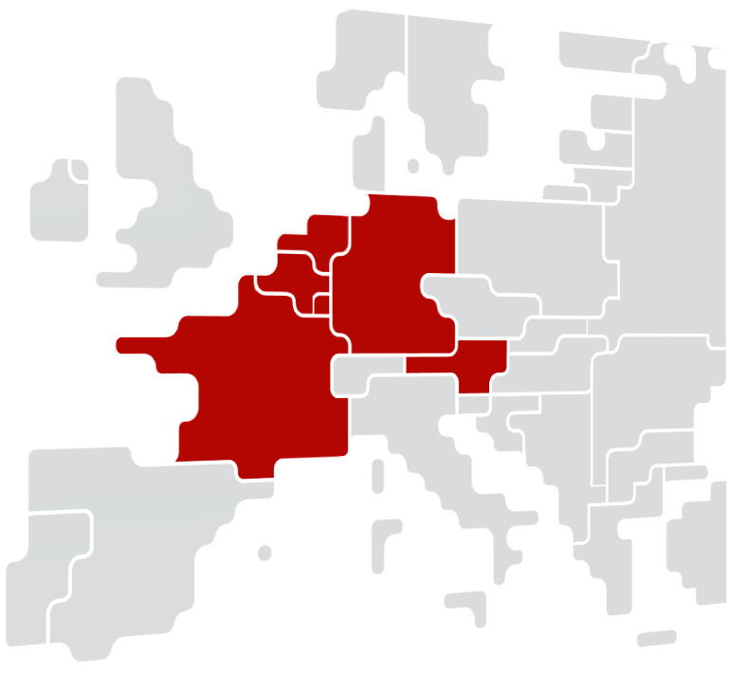

##### Version, date and status

|  |  |  |
| --- | --- | --- |
| **Version** | 1.0 | |
| **Date** | 10-09-2020 | |
| **Status** | Draft | Final |

**Content**

1. Introduction 4

2. CWE flow-based market coupling 6

3. What are ‘flow-based plain’ and ‘flow-based intuitive’ market coupling? 6

4. Drawbacks of the intuitive patch 8

5. Reasons for switch to Flow-based plain 9

6. Implementation timeline 9

# Introduction

**History of implementing flow-based intuitive in CWE FB market coupling**

With the Central Western Europe (CWE) region[1] being the first region applying a flow-based day-ahead market coupling approach in Europe since May 2015, it came along with new structures and processes for market participants (MPs). Before using a flow-based approach to represent network constraints, the CWE region was coupled in the day-ahead market under ATC network constraints. ATC constraints provide an easily readable definition of network constraints for MPs and natively ensure intuitive flows (i.e. flows are enforced to go from higher price areas to the lower ones) as individual ATC constraints are independent from each other.

During the development and testing of the flow-based market coupling approach, a high number of non-intuitive flows were observed which raised concerns amongst MPs and endangered overall acceptance of the innovative flow-based approach itself. Therefore, it was decided to implement the so-called *intuitive patch* in 2015 (additional mechanism to enforce flows within the flow-based area to be intuitive), when CWE FB MC went live, and to re-evaluate it after one year of operations.

In the ‘Position Paper on Flow-Based Market Coupling ‘(March 2015), CWE NRAs requested the CWE project parties (TSOs and NEMOs[2]) to prepare a comprehensive report based on a one-year monitoring and comparison between Flow-Based Plain (FBP) and Flow-Based Intuitive (FBI) calculation modes. The aim of this document was to support CWE NRAs decision to “consider if a change towards the other version of the methodology [was] relevant and justified”. In this regard, a *parallel run* was setup and operated by EPEX SPOT (consisting in the re-execution of market coupling sessions each day, with the intuitive patch disabled), producing monthly reports for CWE TSOs and CWE NRAs enabling them to compare both sets of results.

This 'FBP versus FBI' report was provided to NRAs in January 2017. No decision to change to FBP was taken, and consequently the FBI approach was continued to be applied.

**Renewed evaluation of flow-based plain and ACER decision on the algorithm methodology, led to a decision to switch to FB plain**

During Q4 2019, CWE NRAs requested CWE project parties to update the 'FBP versus FBI' report, considering 4 years of data and including one full year of data after the split of the joint DE/LU and AT bidding zone. CWE NRAs also requested to include considerations related to performance of the market coupling algorithm Euphemia, to elaborate on how to deal with possible situations with an overall negative congestion income in CWE and a high-over project plan to switch to FBP.

The CWE project parties published a second FBP versus FBI report to CWE in February 2020. Compared to the one-year analysis of the 2017 FBI vs FBP report the analysis performed for the second report showed a slightly higher occurrence of the activation of the intuitive patch than in the 2017 analysis. FBP calculation mode still slightly outperforms FBI calculation mode in following indicators: welfare, total daily exchanges, PRB number, total MCV and time to first solution (algorithm performance). On exceptional market coupling conditions (high price spike and low price spike), the produced indicators reflect more contrast and most indicators on FBP mode still outperform indicators on FBI mode. In addition, the indicators show that FBP mode compared to FBI mode could be more beneficial to small markets (BE) and large markets (DE) during exceptional market coupling conditions.

On 30 January 2020, ACER took a final decision on the NEMO proposal for the price coupling algorithm and for the continuous trading matching algorithm, also incorporating TSOs’ and NEMOs’ proposals for a common set of requirements (‘Algorithm methodology’), in accordance with Article 37 of the CACM Regulation. In this decision, ACER concluded that the requirement for intuitive flow-based approach does not have a legal basis in the CACM Regulation and has a significant impact on the SDAC algorithm. Therefore, ACER deleted the related paragraphs from the proposed Common set of requirements for the price coupling algorithm.

Based on this second report and in combination with the reasons mentioned above, through ACER decision on algorithm methodology, the switch to flow-based plain mode has been agreed upon by CWE NRAs.

**Purpose of this explanatory note**

This explanatory note was drafted by CWE project parties to explain to MPs:

* The history behind the decision to implement the flow-based intuitive approach in the CWE region (introduction)
* Explain why under flow-based network constraints non-intuitive exchanges (from high price to low price zones) can occur, and what are the differences between flow-based plain and flow-based intuitive (section 2 & 3)
* Explain drawbacks of the flow-based intuitive approach and the reasons to switch to the flow-based plain approach (section 4 & 5)
* High over implementation timeline for the switch to flow-based plain (section 6)

# CWE flow-based market coupling

To understand what constitutes the flow-based market-coupling process, please be reminded that the CWE Flow Based Market Coupling (FBMC) process is essentially a model of all relevant cross-zonal and internal lines that may limit the grid on a forecasted day. This forecast is used to determine how much capacity is allocated to the market. This section further unpacks this process.

The calculation of the capacity to be offered for the allocation happens in D-2. In the process, all TSOs deliver their parameters. These consist of inputs such as any planned outages, production forecast, and expected renewable infeed. All the parameters together are used to create the reference for the day.[3] The parameters are then combined into a so-called flow-based domain being a concatenation of all the relevant constraints, where the identified limitations are taken into account. For current CWE, this results in a domain with five dimensions. The market allocation takes place within any point of the domain.

CWE TSOs use this first determined domain as a basis for coordination between CWE TSOs during the day. The aim of this coordination is to enlarge the FB domain while ensuring that the domains respect the criteria for security of supply and the minimum capacities, such as long-term rights and minimum capacity over a network element (so-called minRAM).

The end of the CWE TSO process results in a final domain, which is submitted for the market coupling calculation. These are reflective of the domain structure, rather than simply using ATC transfer for cross-zonal capacities. Most notably, branches have a sensitivity factor assigned to them, the Power Transfer Distribution Factor (PTDF). The aim is to allocate the exchange between hubs on the factors. Each factor represents how much of the overall exchange should go over the given branch. This more expressive model of the network (compared to ATC constraints) allows for a more precise allocation of the capacity via the market coupling calculation, closer to the real-world physical constraints.

The eventual flows depend on the outcome of the matching of bids and offers in the market coupling calculation. The next chapter details the difference between the Plain and the Intuitive mode.

# What are ‘flow-based plain’ and ‘flow-based intuitive’ market coupling?

The input data for the market coupling algorithm using the flow-based (FB) approach consists of flow-based domains, expressing the sensitivity of critical network elements towards net values (sum of supply and demand) of each of the coupled bidding zones. Where the ATC-values have to take into account the worst-case combination of cross-zonal exchanges, flow-based domains allow higher exchanges whenever the worst case does not occur.

Flow based domains have as many dimensions (n) as bidding zone borders in the respected area and illustrate the n-dimensional room in which a market coupling solution can be found without having an overload in the grid.

Under the FB approach, an exchange from market A to market B does influence other exchanges. Figure 1 illustrates a two-dimensional flow-based domain and the red dot shows one possible clearing point (or market coupling solution). The red arrows indicate directions the solution cannot move to (outside the domain); the green arrows indicate direction the solution can move to (inside the domain). As long as there is no unique price reached for the market areas involved, the clearing point will move along the borders of the flow-based domain.

The horizontal arrows illustrate that the exchange from A to B can only be increased. If the exchange from A to B is non-intuitive (high to low price), the market clearing point stays in the marked position, since decreasing it is not possible. If the flow from A to B is intuitive, increasing the exchange would lead to an increase of welfare on this border as well as to an increase of the flow from B to C. Therefore, this increase only happens, when a potential welfare loss from increasing the exchange on the B-to-C-border is lower than the welfare gain from the modification of the A-to-B-border which results in an increase of total welfare.

The vertical arrows indicate that the exchange from B to C can only be decreased. If the flow from B to C is intuitive, the clearing point is already in its optimal position. If the flow B to C is non-intuitive (high to low price), it might be an option to decrease this exchange and thereby increase welfare on this border. This would additionally lead to a decrease of the flow from A to B. Therefore, this reduction only happens, when the potential welfare loss from decreasing the A-to-B-border is lower than the welfare gain from the B-to-C-border.

Under the assumption that the marked solution is optimal, it follows that A to B has to be a non-intuitive flow whereas B to C has to be an intuitive one.



**Figure 1: Illustration of FB domain and non-intuitive solution (red dot)**

|  |
| --- |
| **Conclusion**   * Under ATC any exchange is guaranteed to be scheduled from low to high price; * Under FB no general statements can be made on the intuitiveness of solutions; * Non-intuitive exchanges relieve congested network elements, allow more beneficial trades to use these relieved network elements and therefore increase the social welfare. |

To understand the concepts better, below you can find one example of the bidding zones Netherlands (NL), France (FR), Belgium (BE), former Germany/Austria/Luxemburg (DE/AT/LU; ‘DE’ in the example)) and Great Britain (GB) for the timestamps 16/10/2015 h19 and 07/11/2016 h19.

.

**Example (16/10/2015 h19):** To allow the flow based plain solution, bidding zone DE/AT/LU imports from FR non-intuitively. The intuitive approach solves this, by creating a price convergence between DE/AT/LU and FR and reducing exports from NL to zero. The reduction in DE/AT/LU imports reduces the BE imports, and results in price increase from €91 to €280 in BE.

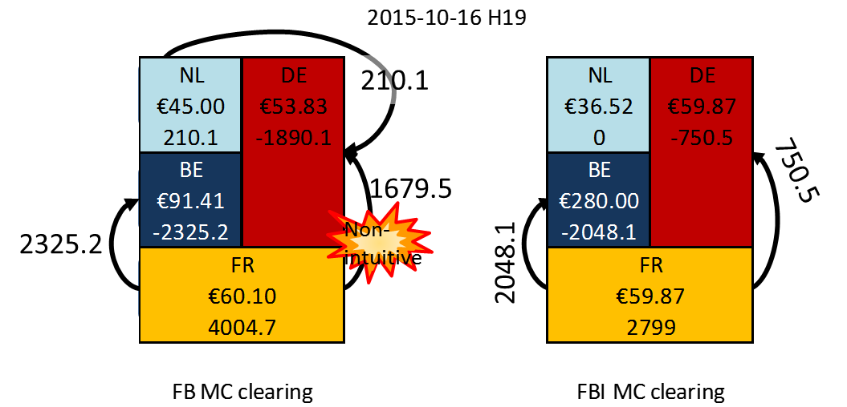

**Figure 2: Example 1**

4For the detailed comparison, please consult the CWE REPORT: COMPARISON FLOW-BASED PLAIN AND FLOW-BASED INTUITIVE: https://www.jao.eu/support/resourcecenter/overview?parameters=%7B%22IsCWEFBMCRelevantDocumentation%22%3A%22True%22%7D

# Drawbacks of the intuitive patch

While providing results which appear more consistent (or intuitive, as the name suggests), the intuitive patch is a mechanism which leads to solution rejections. Discarding these solutions have two main drawbacks. First, it tends to decrease the performance: rejecting a solution, the algorithm needs to find another candidate solution, which may take time (plus: the algorithm needs to define additional constraints to discard the previous solution). Second, solutions with better welfare may be discarded: the intuitive mode is therefore less optimal in terms of social welfare than the plain mode.

From a practical point-of-view, the drawbacks mentioned above reveal to have a higher magnitude whenever the flow-based model increases in complexity as explained in the next section.

# Reasons for switch to Flow-based plain

In light of the current ACER Decision No 04-2020 on Algorithm methodology and considering that the removal of the intuitive patch will induce various improvements (a higher welfare, a better price convergence, the avoidance of price spike situations, a higher utilization of the grid and a better algorithm performance), CWE project parties support a switch to FBP.

Applying the intuitiveness patch, as described above, decreases social welfare and therefore is a deviation from the overall aim of maximizing it. In the monitoring reports mentioned in Introduction section, it can be observed that the average welfare gap is limited when considering a large period in time; however, there are single days where this gap is significant.

The flow-based model structure is also evolving. From the initial definition in 2015, it complexified after the Germany-Austria split (October 2018). In Q4 2020, the new direct current cable (HVDC) ALEGrO between Belgium and Germany/Luxemburg will go into operation and with it, the new so-called evolved flow-based approach (allowing to express a cable under ATC constraints within a surrounding flow-based area). Under this new setup, that will benefit to market participants through increased adequacy and better price convergence, the switch to FB Plain will allow the scarce computation time to be used more efficiently.

Generally, it can be said that utilization of the grid using the plain mode is higher. Especially the utilization of the upcoming ALEGrO interconnector implemented following the evolved flow-based approach is significantly higher, anticipating the EU goal of a well-functioning internal market.

# Implementation timeline

The implementation of FB Plain is set to go live simultaneously with the ALEGrO technical implementation. This technical go live of this new interconnector is planned on November 3rd, 2020 for a delivery day November 4th (commercial go live expected mid-November 2020. Exact date will be communicated at a later stage by ALEGrO project parties).

First delivery day with FB Plain (allocation on 3/11)

Procedural & regional tests for ALEGrO/FB plain

Functional tests for ALEGrO/FB plain

Novermber 4

October

September

1. The CWE region consists of the countries: Austria, Belgium, France, Germany, Luxembourg and the Netherlands
2. At the time CWE day-ahead flow-based market coupling was developed, the involved power exchanges (APX group and EPEX SPOT) were not yet designated as NEMO.
3. For the complete set of parameters and process description, please consult the CWE FB DA approval package: <https://www.jao.eu/support/resourcecenter/overview?parameters=%7B%22IsCWEFBMCRelevantDocumentation%22%3A%22True%22%7D>