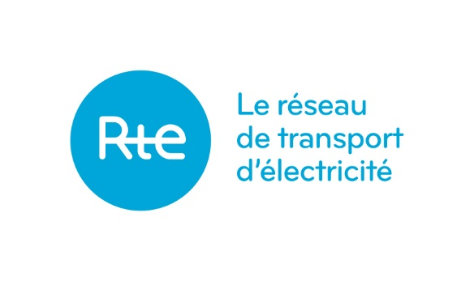

Following a successful auction split in 2024, RTE and Elia are pleased to announce that the France-Belgium yearly capacity for the delivery year 2026 will be split and offered into two separate auctions. The first one will be held in June 2025 and the second one end of Q4 2025.

The details of the second auction (end of Q4) will be communicated at a later stage.

As for the June auction, you will find the details below (timings in CET):

|  |  |  |  |  |  |  |  |  |  |
| --- | --- | --- | --- | --- | --- | --- | --- | --- | --- |
| **Bidding Month** | **Interconnector** | **Product** | **Horizon** | **Volume (MW)** | **Auction Start** | **Time (of the opening)** | **Auction End** | **Time (of the End)** | **Dispute period** |
| June 2025 | BE->FR | Y BASE 1 | 2026 | 125 | **10/06/2024** | 13:50 | **17/06/2024** | 13:50 | 2-2 days |
| June 2025 | FR->BE | Y BASE 1 | 2026 | 700 | **10/06/2024** | 13:50 | **17/06/2024** | 13:50 | 2-2 days |