JIRA Service Desk –
Introduction

Introduction/Overview

The JIRA Service Desk is dedicated for customers to raise any request that belongs to their activity using the services of JAO. JIRA Service Desk is the first point of contact and main mean of communication of JAO operators with market participants. Using JIRA is facilitate solving of the issues as you as market participant will always be able to see the status and progress of the issues raised. All JAO operators are able to see and work on an issue raised. Users are able to make a comment on the ticket. In case of any questions for the user, a JAO Operator will contact the user via JIRA or even raise an issue assign to a user, or group of users, making the progress transparent for all sides involved. Users are able to upload files and documents on JIRA with simple drag and drop making the use of JIRA Service Desk intuitive and easy to use. The users from the same company are able to see issues raised by their colleagues that makes the communication easier.

Registration

In order to get access to the platform, you need to register first here (or copy the link into your browser https://servicedesk.jao.eu/ ).

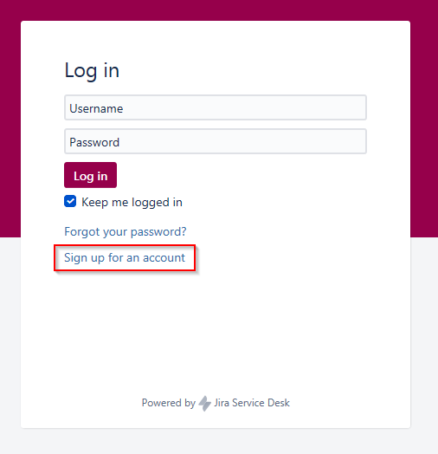

If you don’t see this option you may click on top left corner of the page “JAO Service Desk”, that will redirect the page to the home screen (picture above).

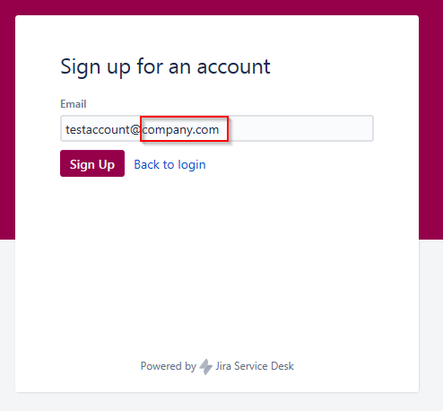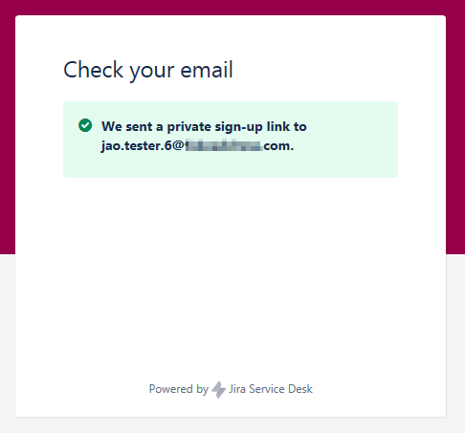

For easy identification, make sure you register with your corporate email address registered in eCat – Auction Tool, if you have an account there. After this step you should receive a confirmation email, click on sign up to complete the first registration step.

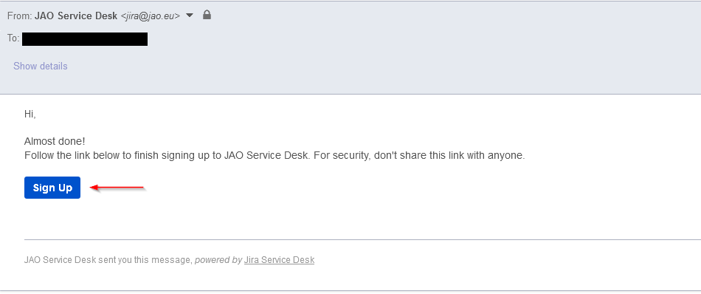

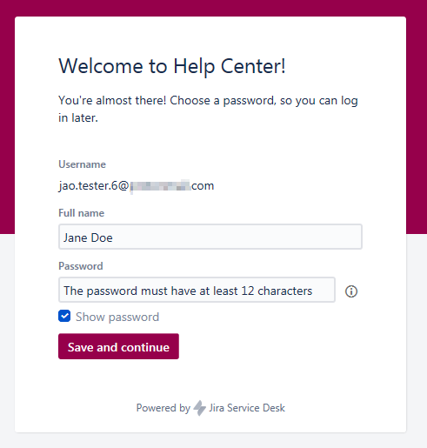

Please enter your full name since this will help the next registration step, for the password you can also click on the (i) icon to read the password policy.

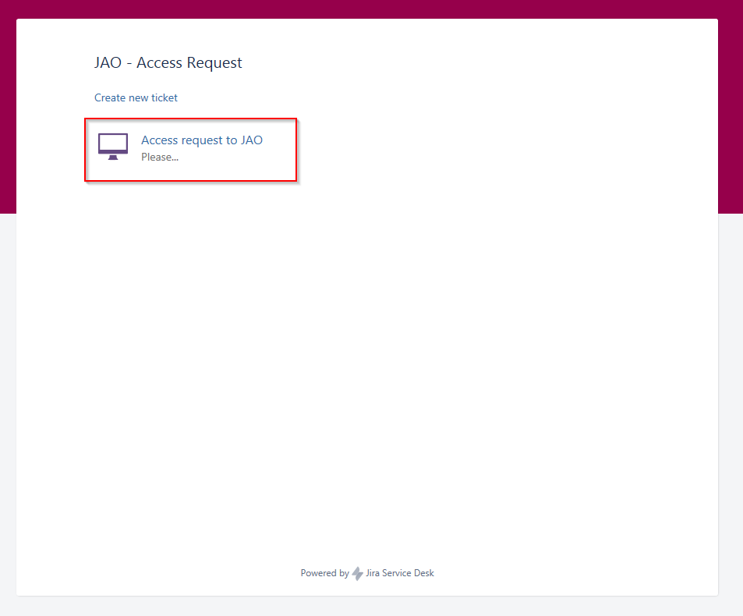

The first time you log in, you will need to request access to JAO, if you are the first person of your company registering you will need to wait for approval from JAO, otherwise if you are not the first person of your company that is registered, another member of your company must accept your access request.

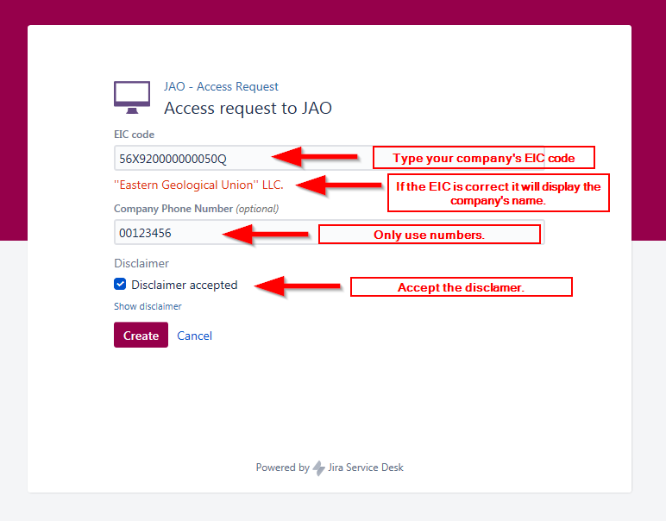

When you finished, click simply on the ‘Create’ button. In order to use JIRA you have to accept the terms and conditions of the usage. This disclaimer will be displayed in a pop up window. Make sure you read it before the acceptance. You will always have possibility to read terms and conditions under your profile page.

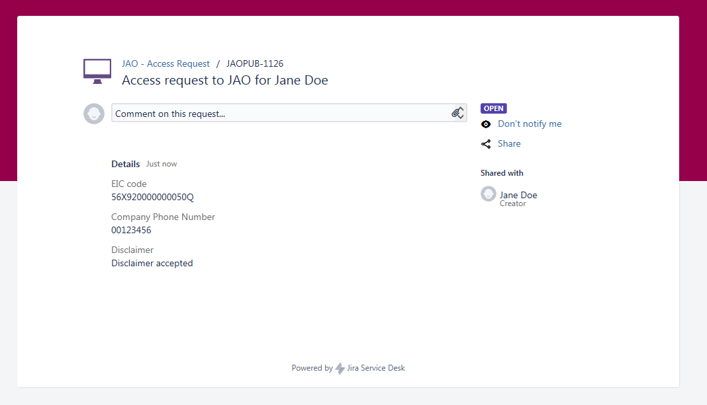

As mentioned above, after creating the access request you will receive an email confirming your access request, and you will have to wait for JAO to approve your request or as we will see below, wait for one of your colleagues to accept your request.

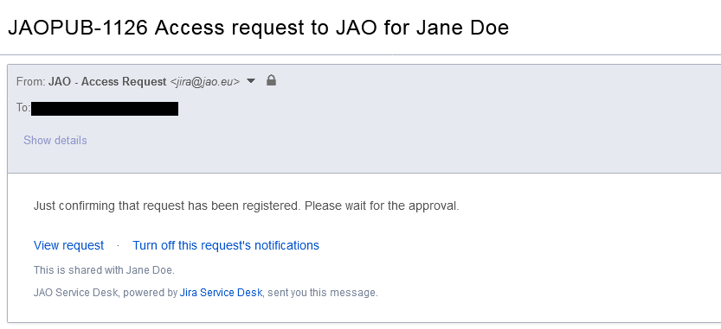

One or more (depending on the registered email addresses for your company) of your colleagues will have received the email below.

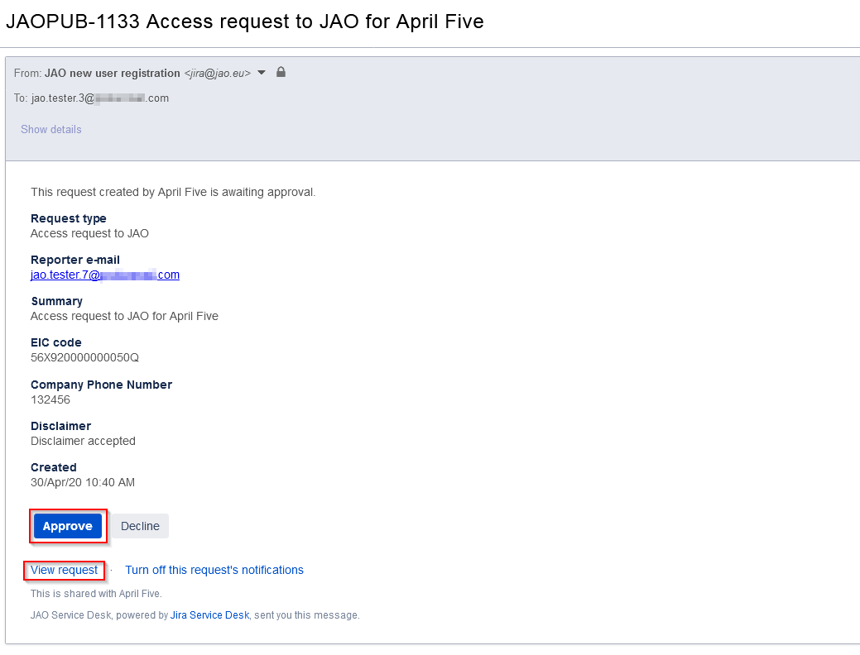

If you do not wish to approve the request directly from the email address, you may click on “View Request” to be redirected to the following page:

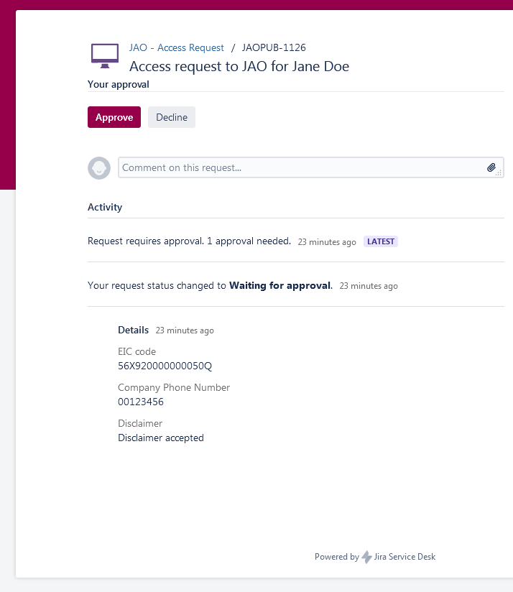

Approving the request will change the “status of the ticket”.

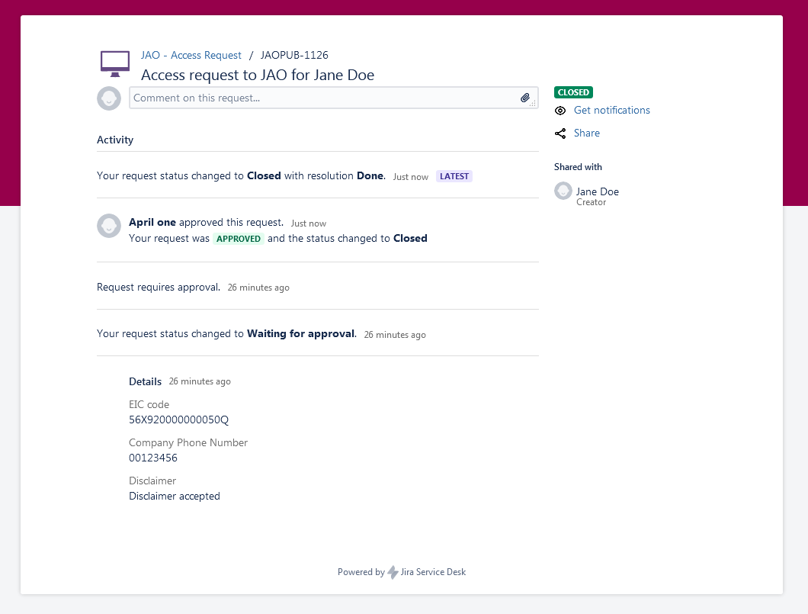

Once the request is approved, the user and all the members of the company will be notified of this access approval.

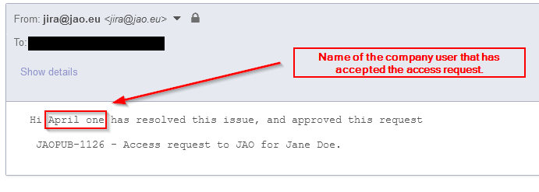

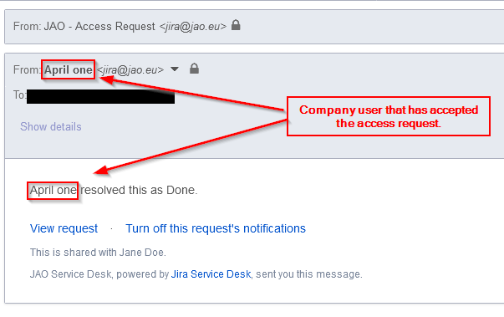

Once you receive this email you will have completed the registration process, and you will be able to fully use JIRA to raise tickets, questions, requests etc.

Customer Portal main page
Sign up with your credentials and you will be redirected to the main JIRA page of the Customer Portal.

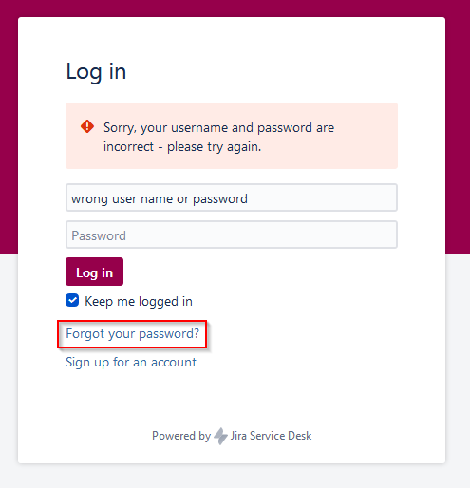

In case you forgot your user name or password, you have the option to retrieve those using the link ”Forgot your password?”

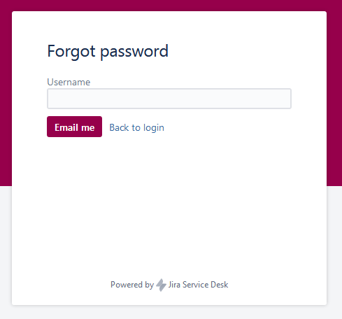

Provide your username (it may be the same as your email address) used during registration.

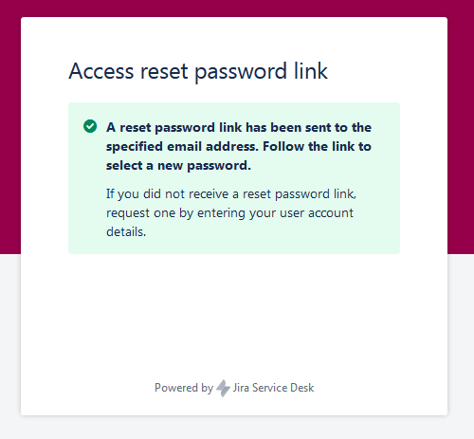

The e-mail with the link allowing you to reset your password will be sent to that e-mail address, as shown below.

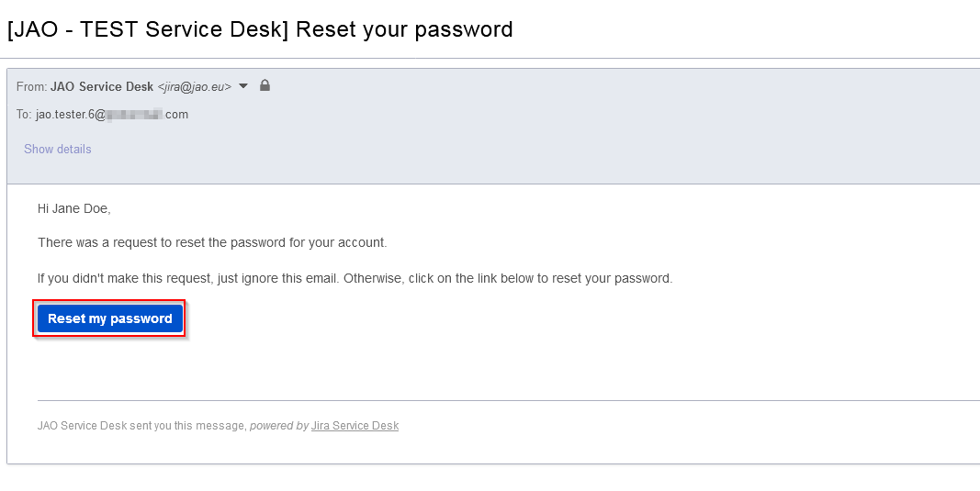

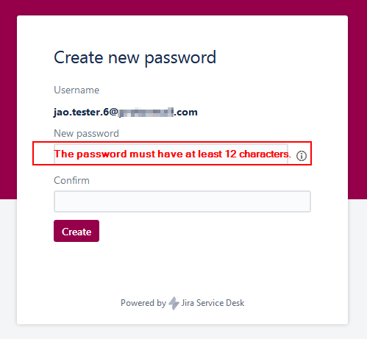

After changing the password you will gain immediate access to the platform.

- Two factor authentication (2FA) for Jira

For the initial setup use the URL: https://servicedesk.jao.eu/ this will redirect you to the log in page.

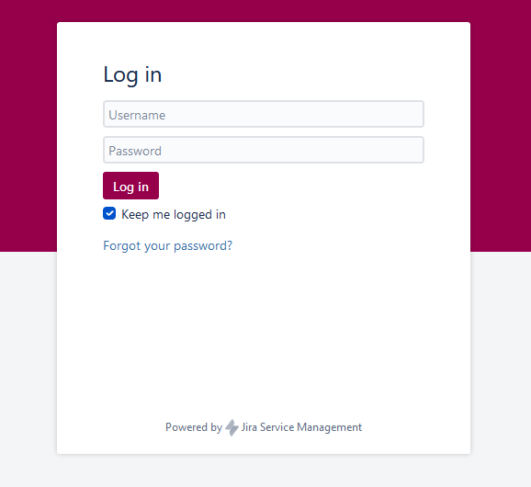

After entering your user credentials you will be redirected to the page that shows the 2FA method that needs to be configured:

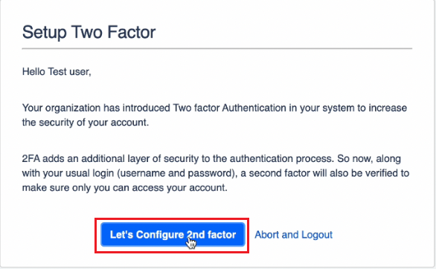

By pressing on “Let’s configure 2nd factor” you are redirected to the selection page:

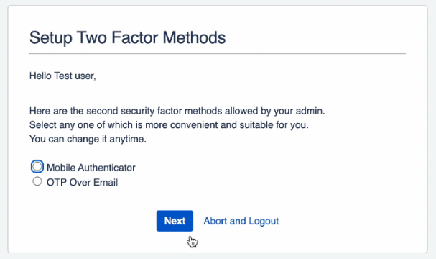

You have two options to select from to define your primary 2FA method:

Option 1: Mobile Authenticator:

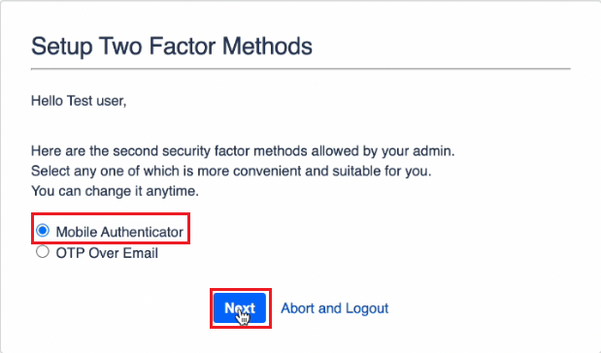

After clicking on the Mobile Authenticator radio button and clicking on next, a pop-up window will show you which mobile applications supports this method on what type of OS. For both iOS and Android users the app Google Authenticator is a viable option:

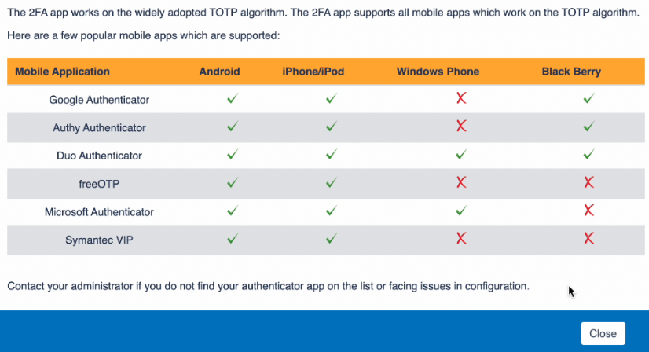

Closing this window will show you the QR code that must be read by the installed authenticator app (in our case this remains Google Authenticator):

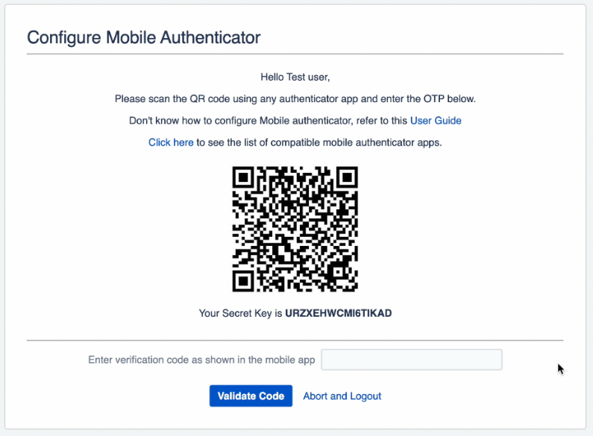

Open the mobile application and select “Scan a QR code”

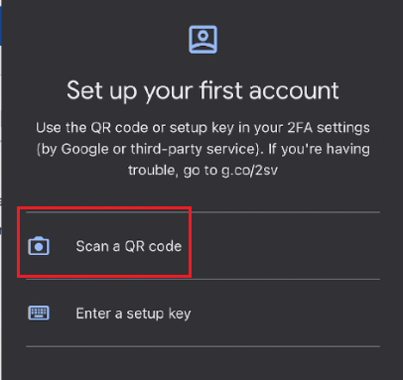

- You are able to read the QR code with the app

The entry immediately appears in the authentication app:

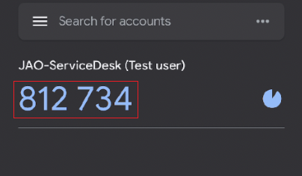

Enter the 6 digits on the Jira 2FA screen and press “Validate code”:

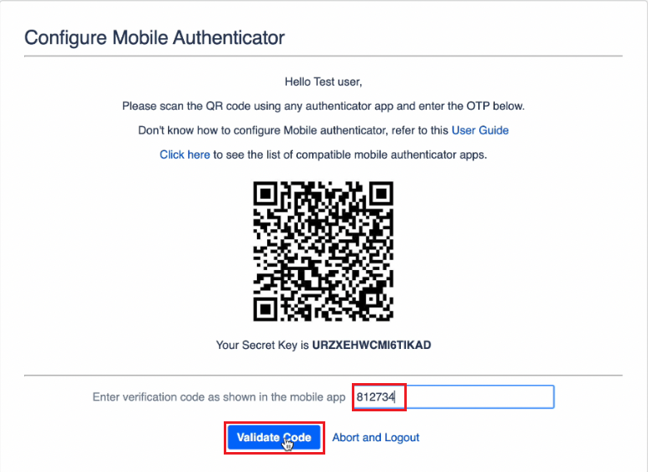
- You are not able to read the QR code with the app

If the QR code could not be read, select the option “enter a setup key”:

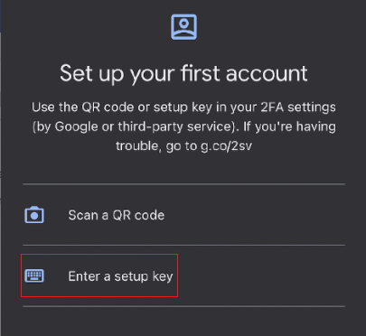

Enter the username to the “Account” field and secret key to the “Key” field. The secret key is displayed below the QR code:

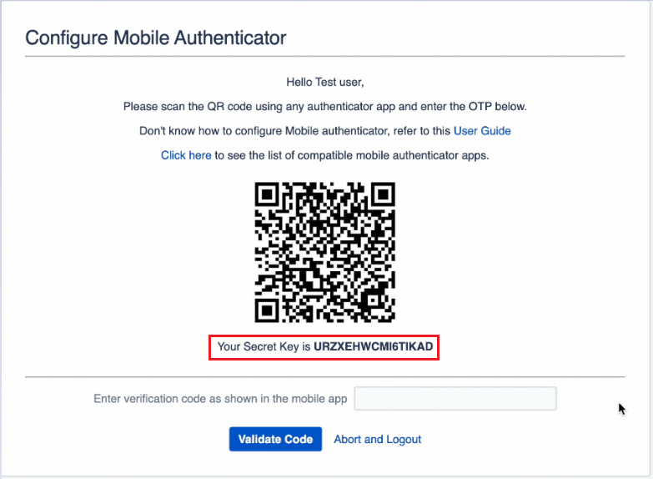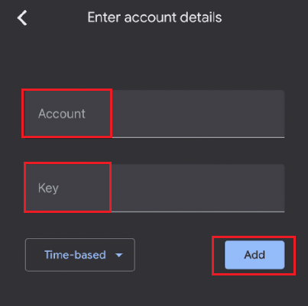

The token will automatically recognized and the 6 digit OTP appears on the screen:

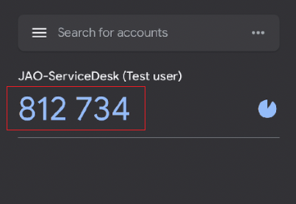
Enter the 6 digits on the Jira 2FA screen and press “Validate code”:

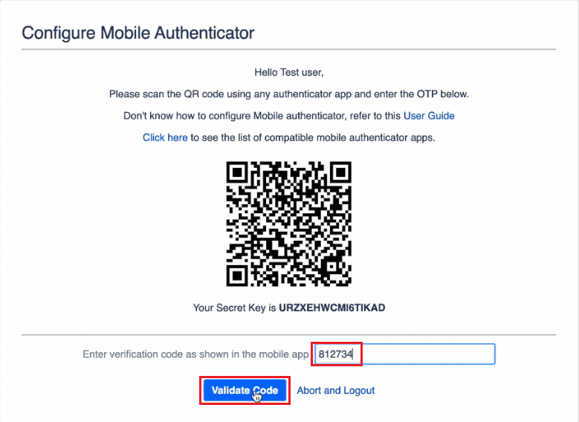

Right after that you need to setup the backup method. This will be used in case your primary 2FA method is not possible for any reason.

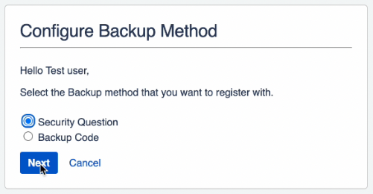

We will set up the security questions as backup method, if you wish to have the backup codes instead, read the following Section “How to Configure Backup Codes”. By clicking on “Next” you will need to set up 3 security questions and respective answers. The last one is custom, so it is on you to define the question and it cannot be skipped.

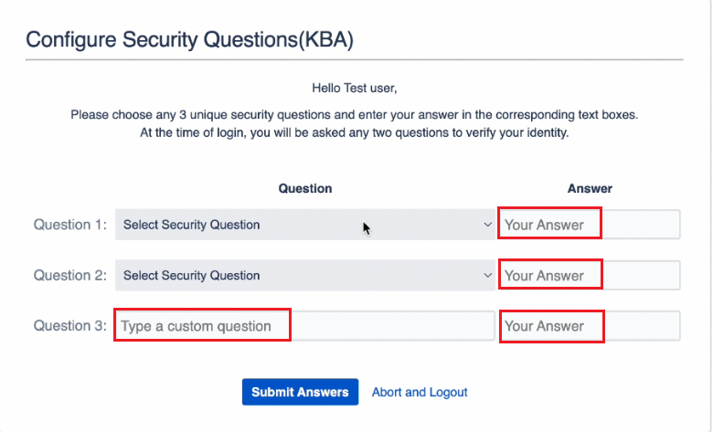
Once you submit the answers you have further options to set up 2FA methods, or skip and finish the process

- Skip the process

Hit the “Skip” button:

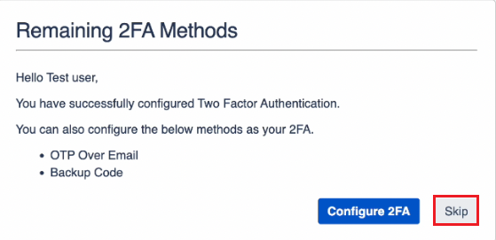

You will be redirected to the external customer portal:

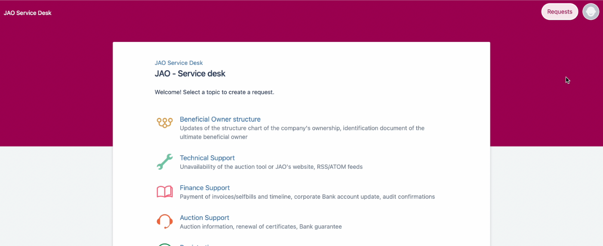

- To configure more methods:

After clicking on “Configure 2FA” you will be redirected to the main page of your 2FA settings under your user account.

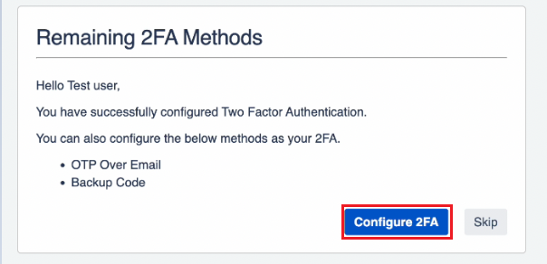

For information on configuring see “Set/Reset/Configure more 2FA methods” section below.

- How to Configure Backup Codes:

Once you have configured the primary 2FA method then if you wish to setup the “Backup Codes” as the Backup method, click on the Backup Codes radio button and click on next. On the screen you will see 15 unique backup/recovery codes.
In the future, in case you lose your mobile phone, then you can use these recovery codes to gain access to your account again. Click on the “Download Codes” button and click on continue. Then store the downloaded file with the backup codes at a secure location.

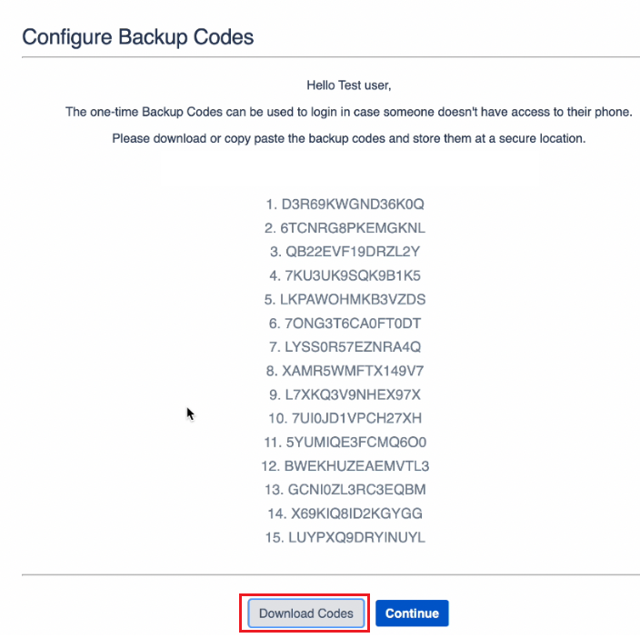

Each backup codes can be used only once. If you have used many back up codes, if you want you can download a new set of backup codes as well. For this, log into your Jira account and go to the Two Factor Configuration page on your profile.

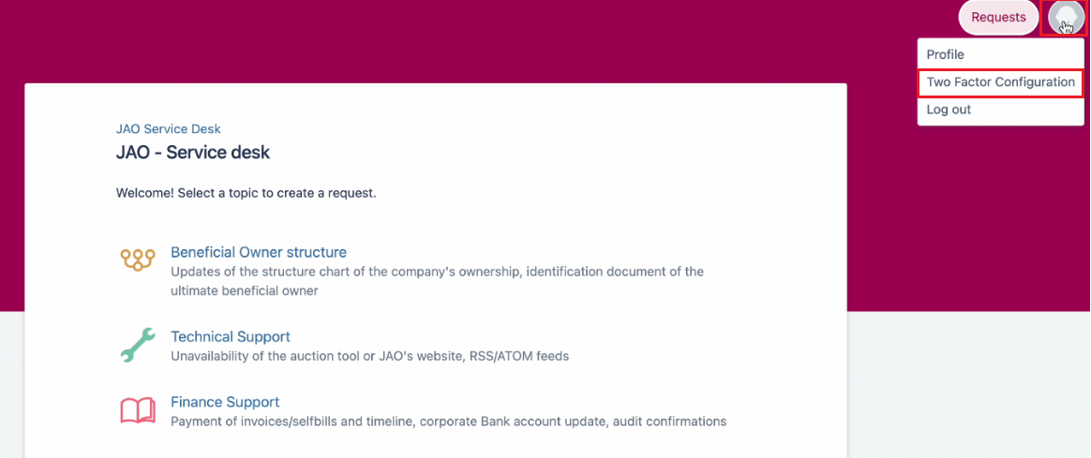

Click on Show Details in the Backup Code (Backup Method) tab and you will see the following pop-up. Click on the Change Backup Code button and download the codes again.

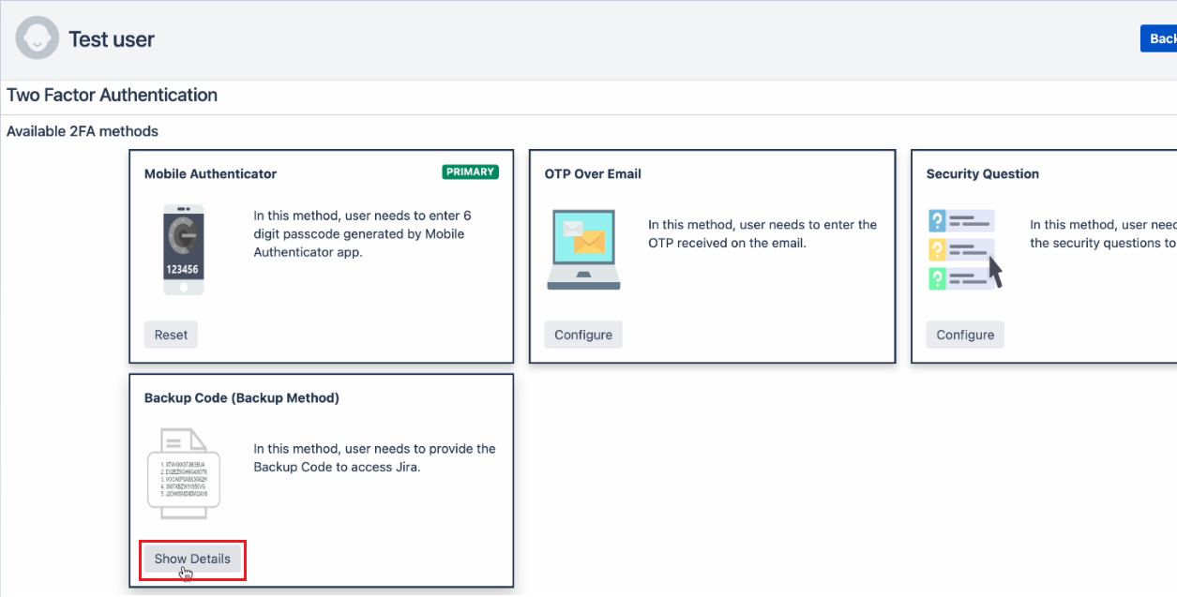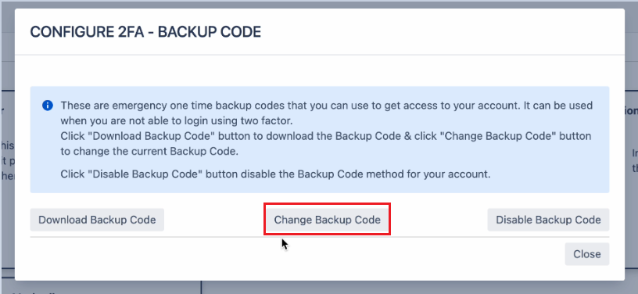

Option 2: OTP over Email:

Select the “OTP over Email” radio button and press “Next”. An email will be send to you with the One-Time Password (OTP) shortly after that:

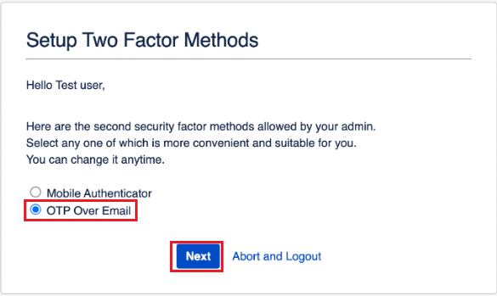
Enter the 6 digit OPT received in the empty field of the “Enter OTP received on email” tab and hit “Validate OTP”

- Make sure you copy only the digits and no extra space has been accidently added.

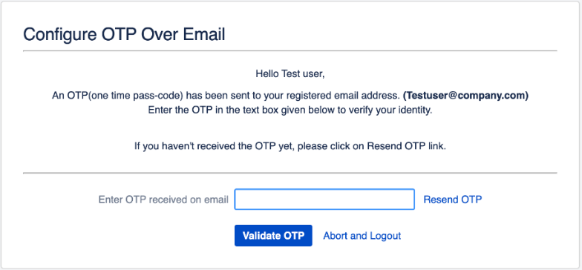

- You got an error:
In case the One-Time Password expired, click on the “Resend OTP” and you will see a confirmation message about the action:

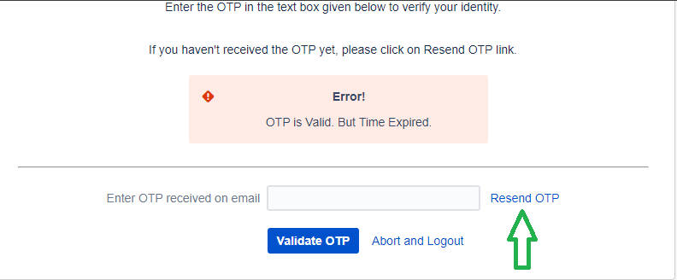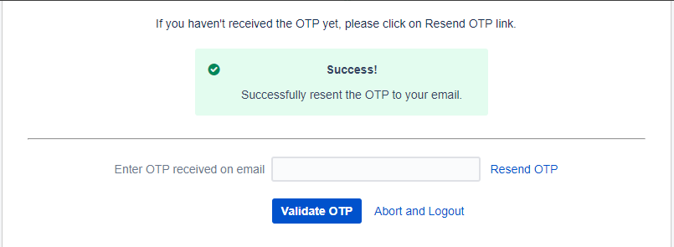

Right after that, you will need to setup the backup method. This will be used in case your primary 2FA method is not possible for any reason.

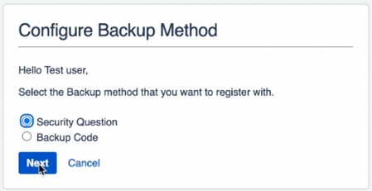

We will set up the security questions as backup method, if you wish to have the backup codes instead, read the following Section “How to Configure Backup Codes”. By clicking on “Next” you will need to set up 3 security questions and respective answers. The last one is custom, so it is on you to define the question and it cannot be skipped.

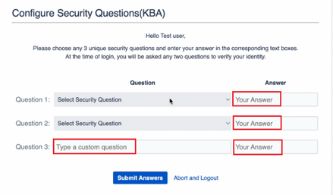

Once you submitted the answers, you have further options to setup 2FA methods, or skip that and finish the process and will be redirected to the external customer portal:

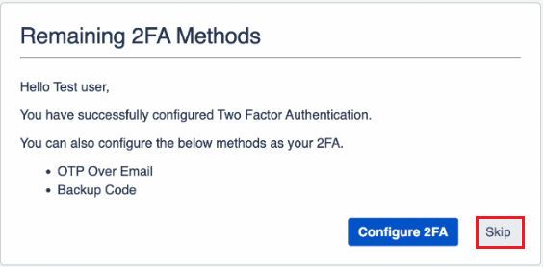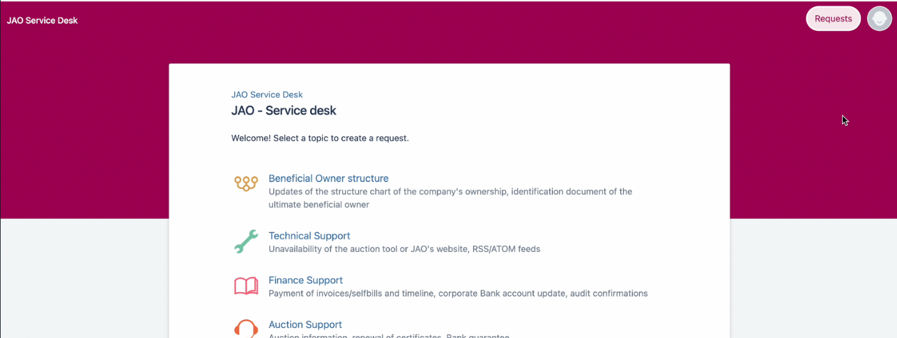

If you want to configure more methods, after clicking on “Configure 2FA” you will be redirected to the main page of your 2FA settings under your user account.

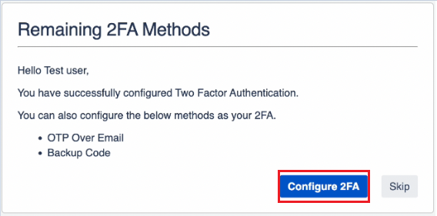

For information on configuring see “Set/Reset/Configure more 2FA methods” section below.

- How to Configure Backup Codes:

Once you have configured the primary 2FA method then if you wish to setup the “Backup Codes” as the Backup method, click on the Backup Codes radio button and click on next. On the screen you will see 15 unique backup/recovery codes.
In the future, in case you lose your mobile phone, then you can use these recovery codes to gain access to your account again. Click on the “Download Codes” button and click on continue. Then store the downloaded file with the backup codes at a secure location.

Each backup codes can be used only once. If you have used many back up codes, if you want you can download a new set of backup codes as well. For this, log into your Jira account and go to the Two Factor Configuration page on your profile.

Click on Show Details in the Backup Code (Backup Method) tab and you will see the following pop-up. Click on the Change Backup Code button and download the codes again.

- How to login with 2FA

Make sure you always use the URL https://servicedesk.jao.eu
Enter your username and password as usual:

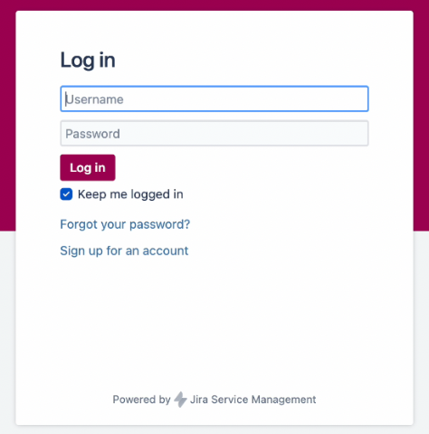

The next window that you will see is the second factor authentication:

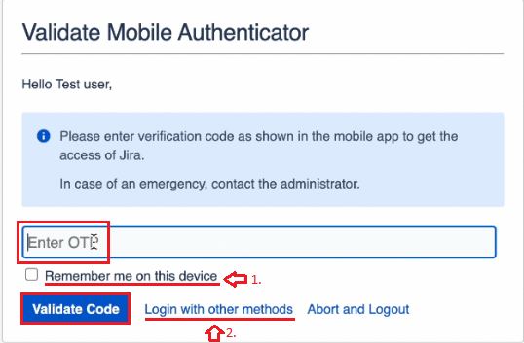

Enter the OPT independently of the method you set.
- You may mark the device as trusted, in this case it will not request 2FA from this device for the next 14 days.
- “Login with other methods: can be used to switch to the Backup Method or any other methods you have set.

- Too many failed attempts
If you had 3 failed attempts to enter your OTP, the account is locked for 15 minutes.

After the validation you are redirected to the internal landing page:

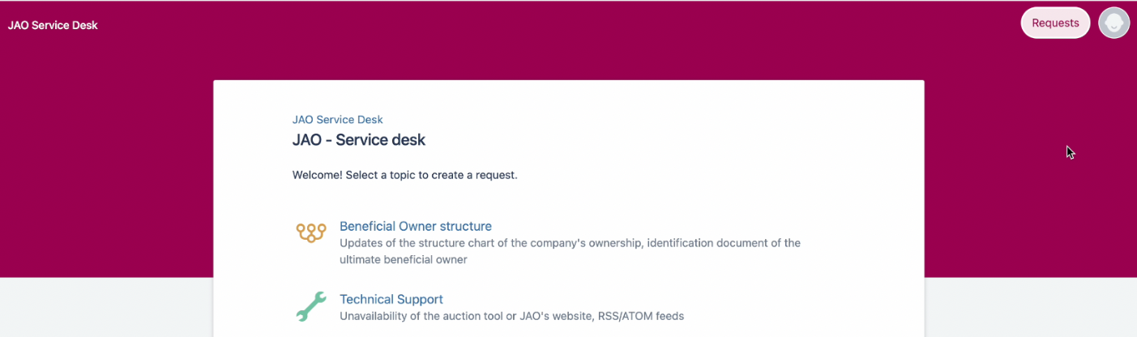

- Set/Reset/Configure more 2FA methods.

You may see this screen either by the initial setup of the 2FA methods by clicking on “Configure 2FA”

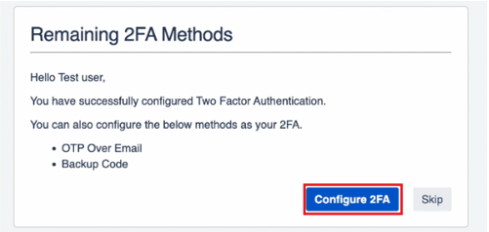

Or manually navigate to this menu to this menu under the user account settings in the top right corner after the login:

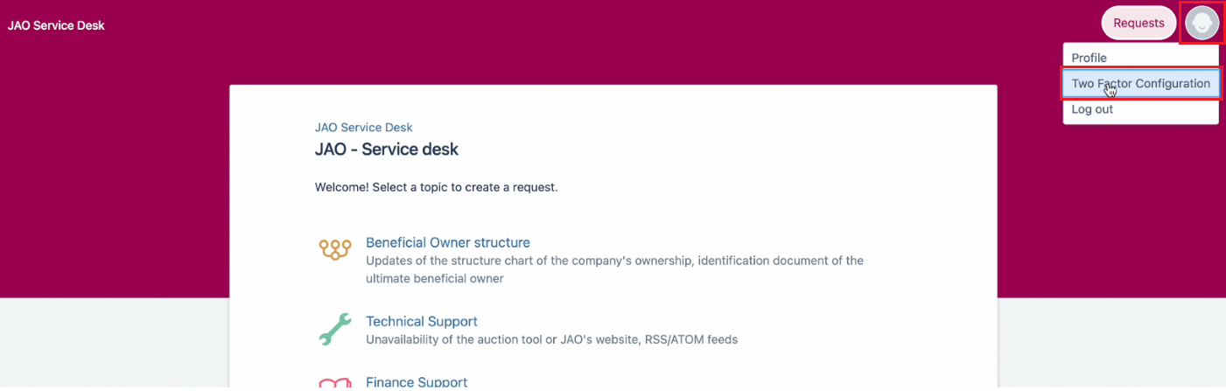

In any case you will get the settings menu:

- Reset:
“Reset” indicates to reset the methods you already configured. When you click on the reset, the button will change to “Configure”.
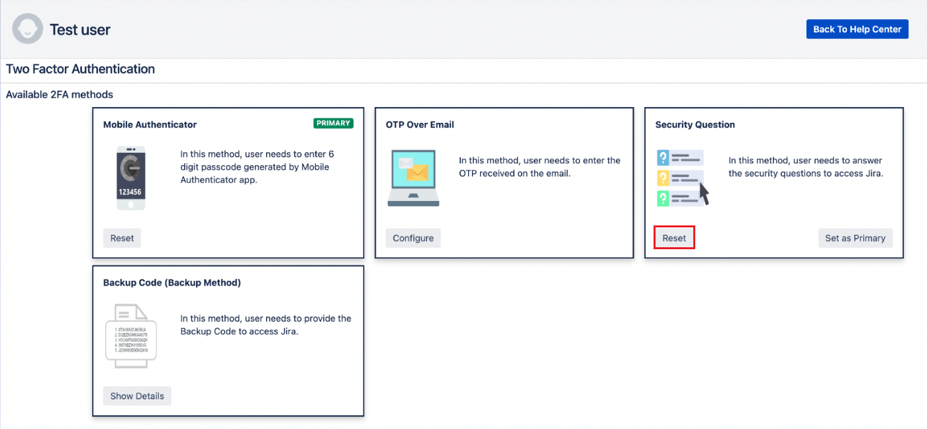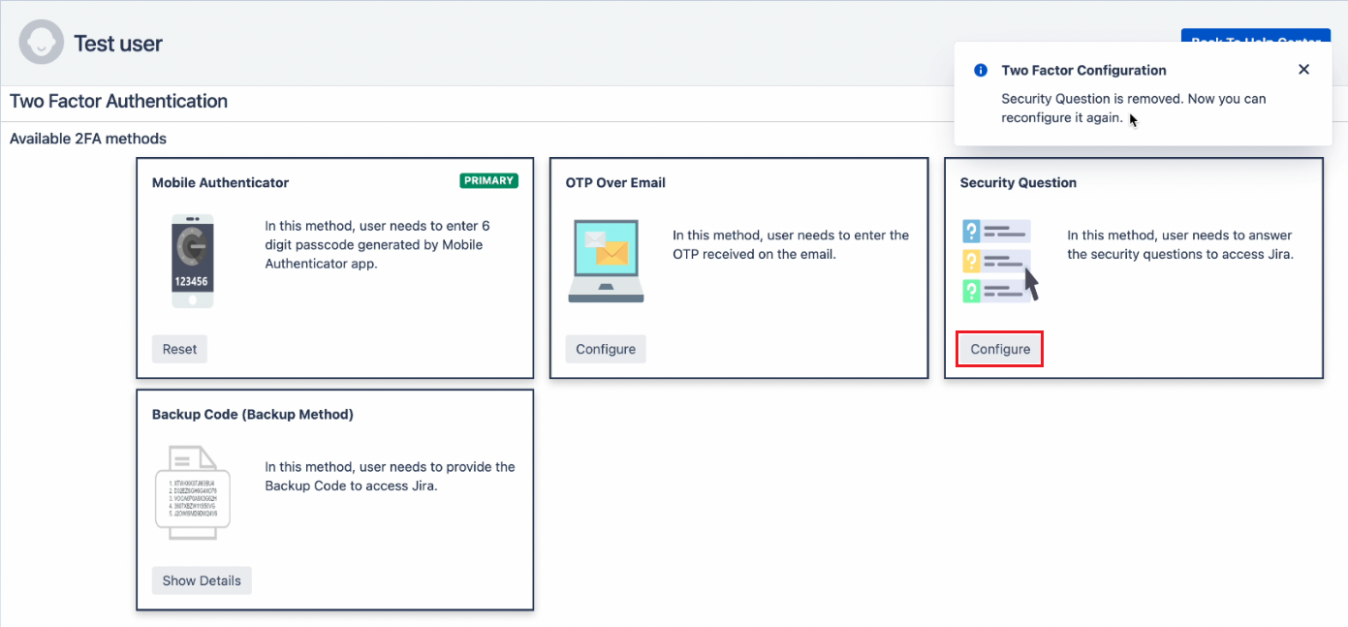

Now you can re-configure directly from this page through a pop-up window:

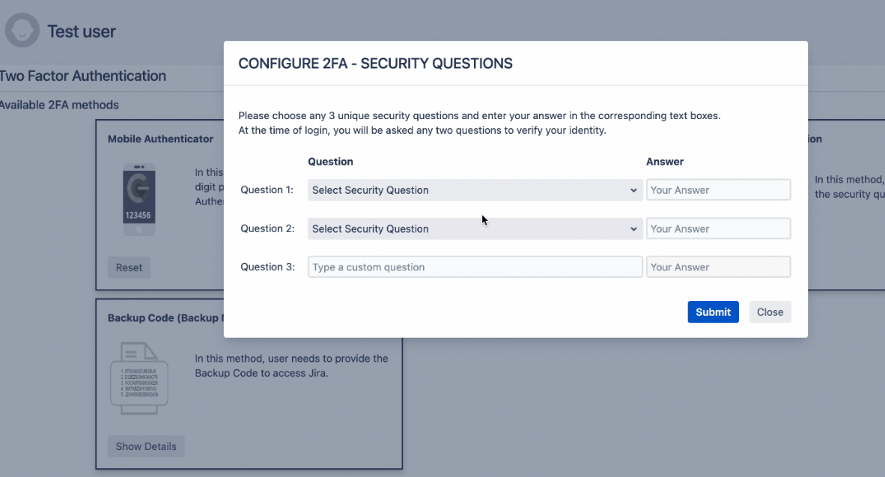

Once it is set, you will get a confirmation immediately.

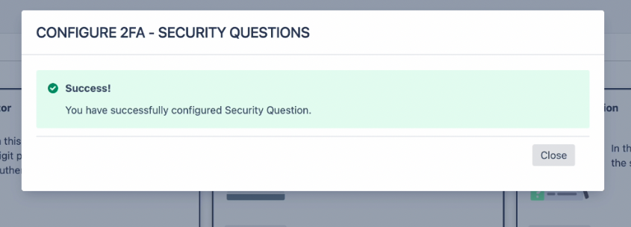
- Set as primary

Your primary method is the default one that appears as the second factor after entering the username and the password. You can change this to any of your method you already configured:

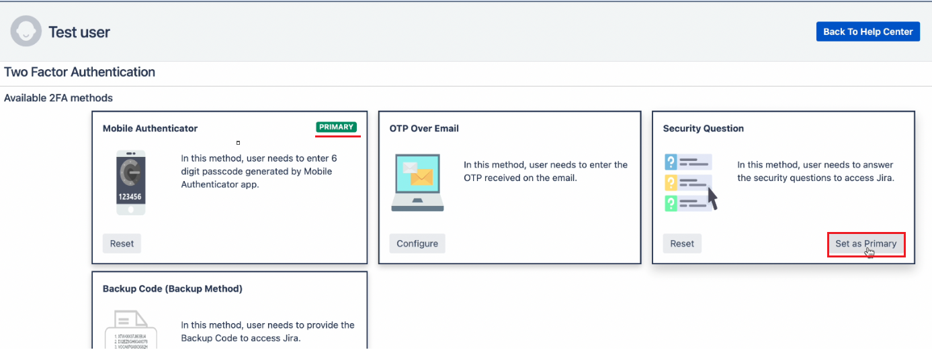

Once you press the button, the changes apply automatically.

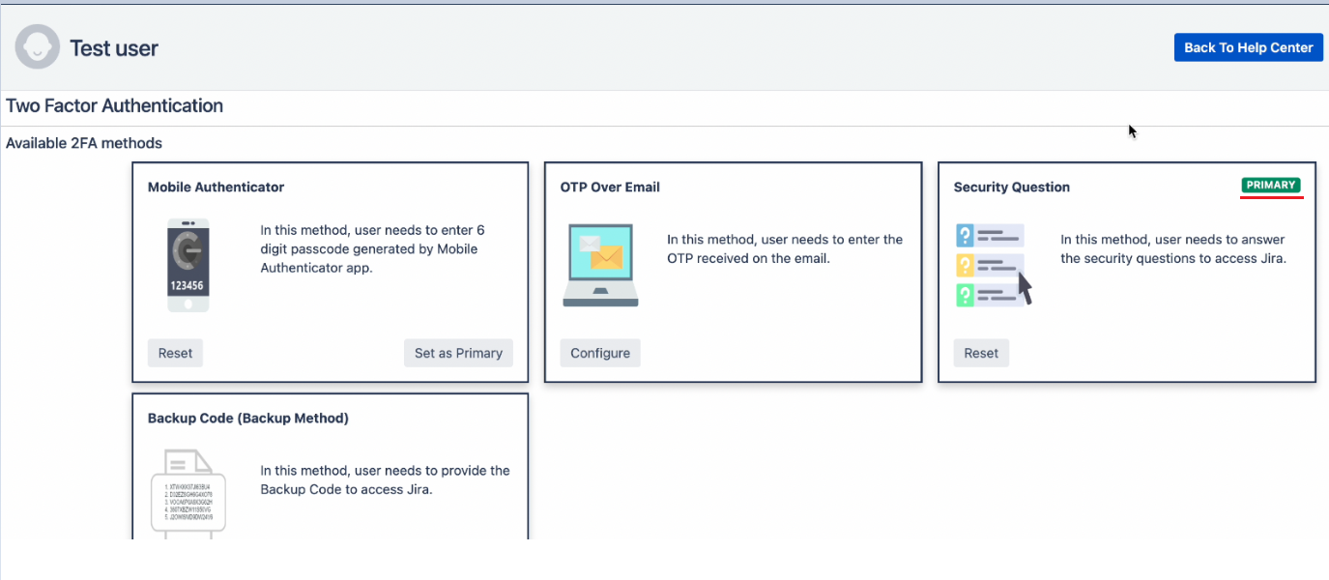
- Configure

Configuring another method can be managed anytime from this menu directly. A pop-up window appears on the screen that helps you setup directly from here:

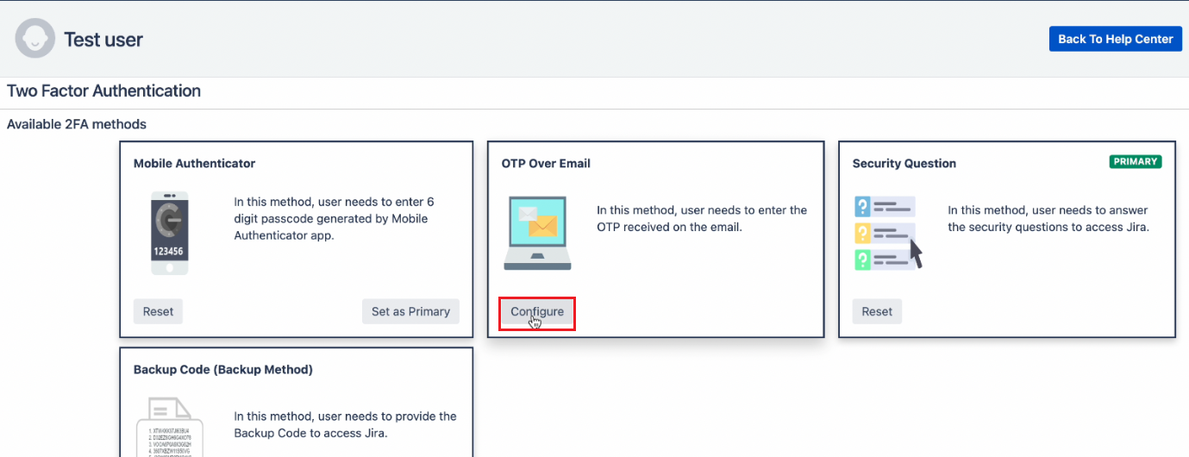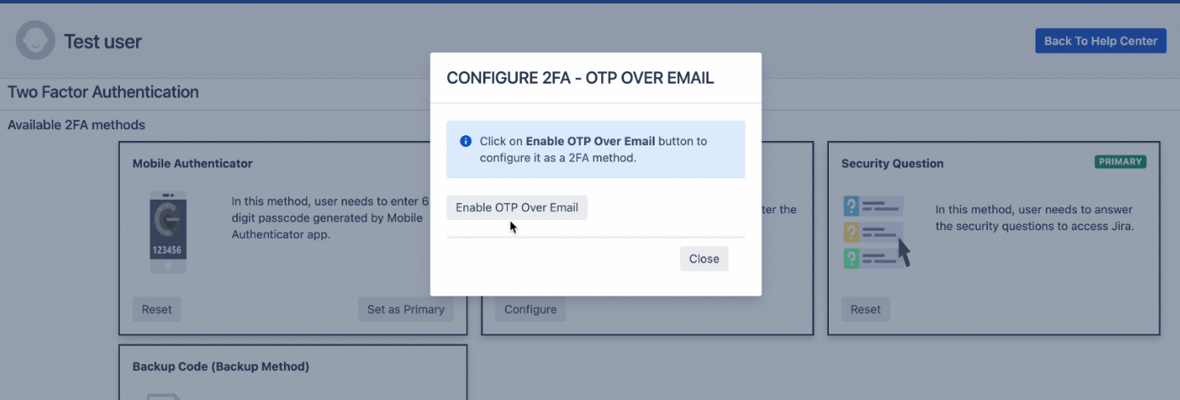

For configuring the Mobile Authenticator, see section “Option 1: Mobile Authenticator”.
For configuring the Backup Code, see section “How to configure Backup Codes”

Creating a ticket
Creating a ticket regarding an issue, select the relevant type:

- Beneficial owner structure – Updates of the structure chart of the company's ownership, identification document of the ultimate beneficial owner.
- Technical Support – Unavailability of the auction tool or JAO's website, RSS/ATOM feeds.
- Finance Support - Payment of invoices/selfbills and timeline, corporate Bank account update, audit confirmations.
- Auction Support - Auction information, renewal of certificates, Bank guarantee.
- Registration – Company registration (incl. participation agreement amendments), auction tool user access.
- Business bank account – Funds transfer request, ING inside Business access.
- Contestation – Contestation of auction results.

Whenever you want to visit this page, just click on the ‘JAO Service Desk’ link at top left corner of the screen.

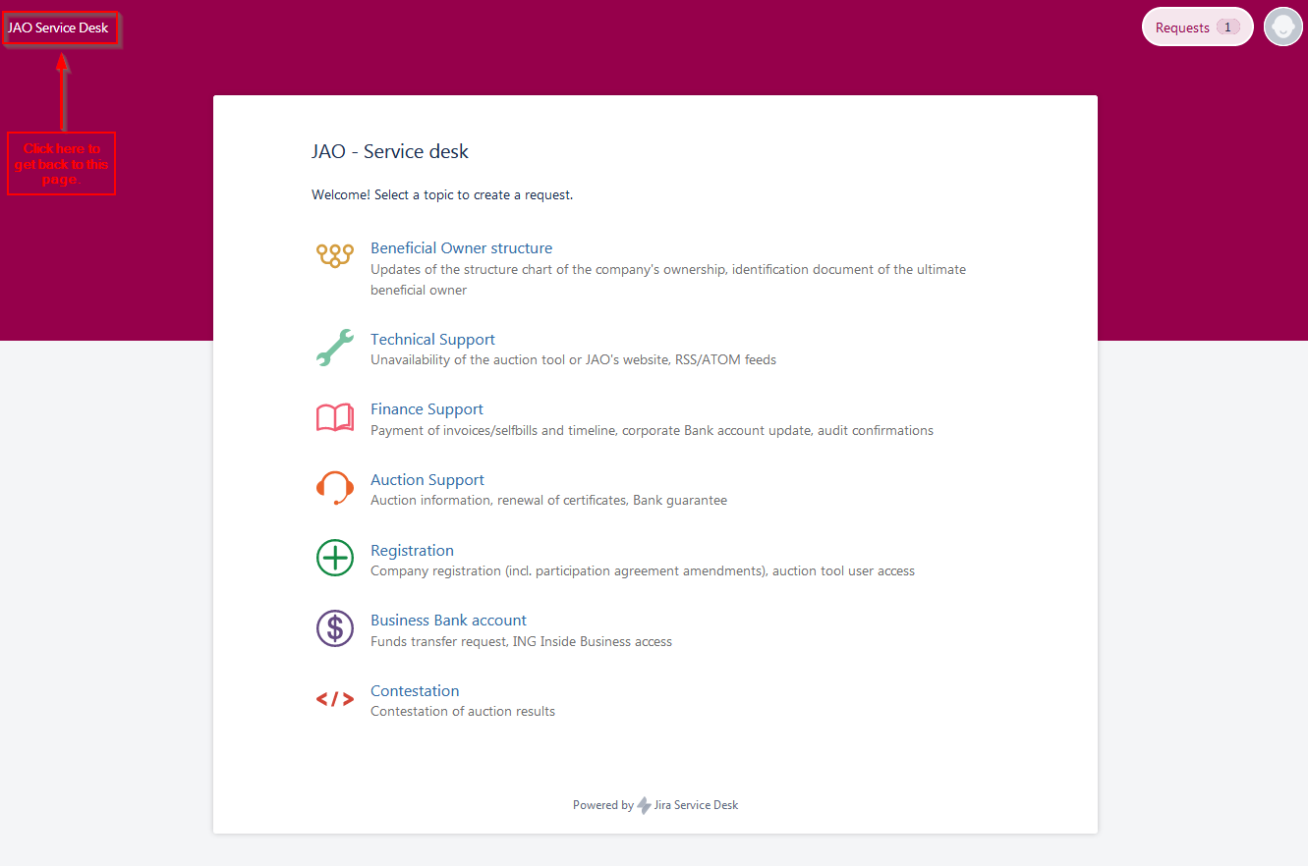

In the following example a Technical Support related ticket was created. After clicking on the relevant category, the request can be detailed on the following page:

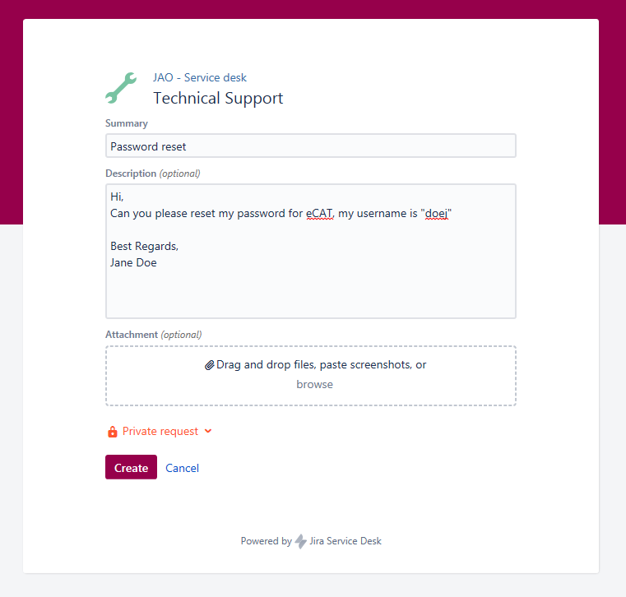

A short summary and a detailed description is essential plus attachments are welcomed as well (there are no file restrictions, .pdf, .jpg, .jpeg, .png, .xlsx, .csv, .xml, .docx, .zip, .cert etc. can be also attached).

The attached files (print screens for better understanding of an issue, certificates, etc.) are easy to upload, using the box Attachment, either clicking on browse and finding a file on your PC, or just by dragging and dropping them in the attachment box.

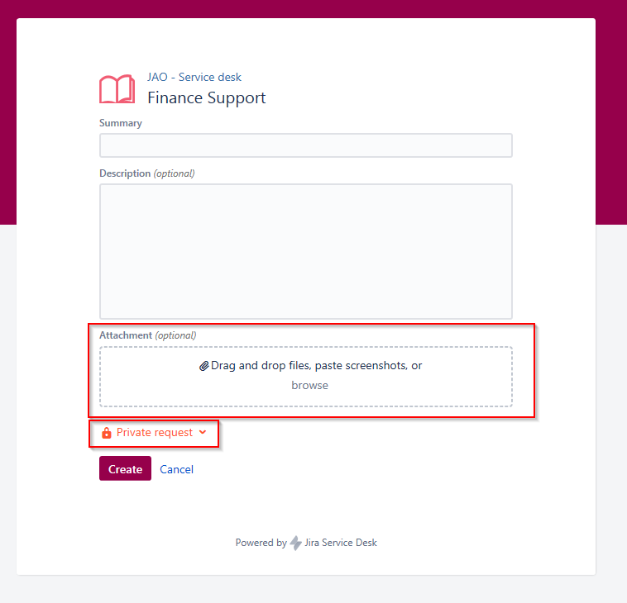

You may also define if the ticket is a private request or if you want to share the ticket with your
colleagues.

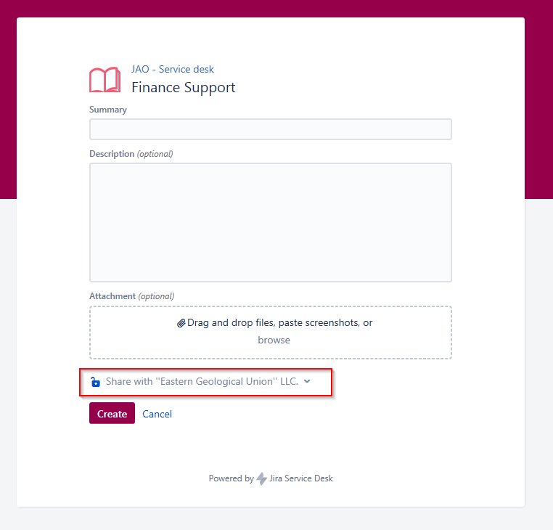

When the ticket is created, it will be automatically displayed, you may add extra comments on the ticket if you feel there is a need for additional information.

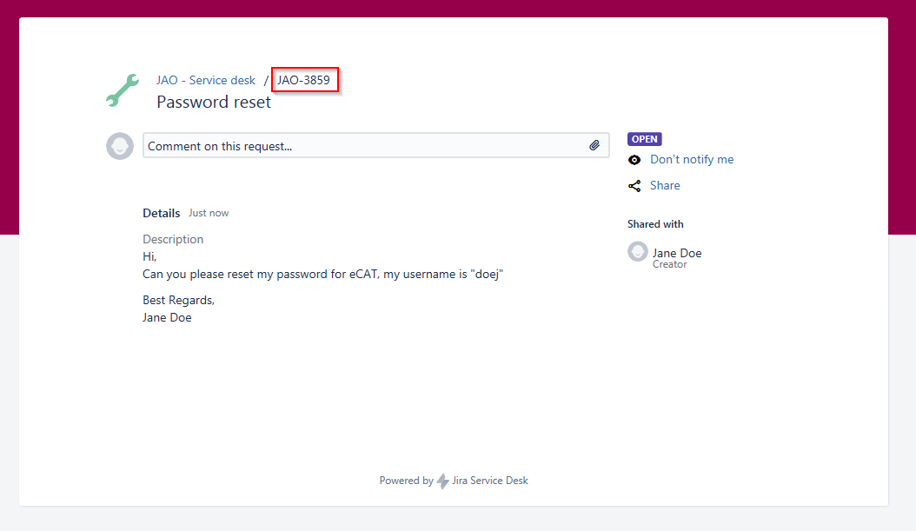

You will see here every status changes (started with ‘Open’) during the ticket lifecycle, all the comments from you and from the JAO Operators will be updated in the ticket. Please note the reference number (at the top) which can be referred to in every case.
Meanwhile, you will receive a notification via email, that the ticket was sent. The email will also include the reference number in the subject on the subject.
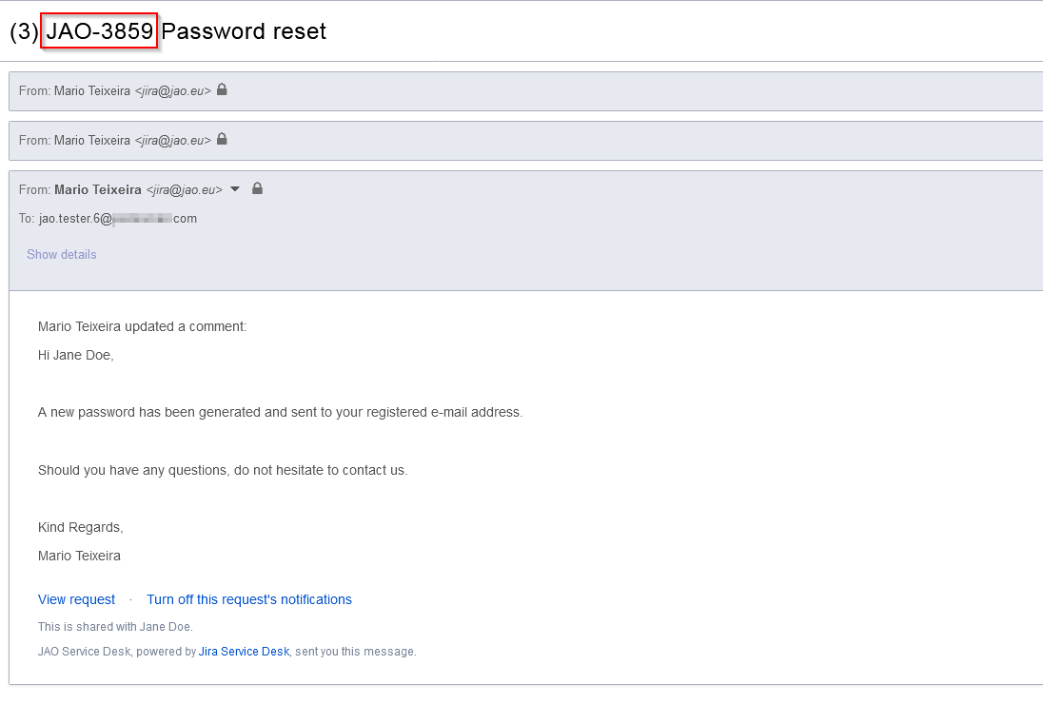

If you want to see your requests, just go top right corner of your page in your browser and click on ‘Requests’ at then My requests.

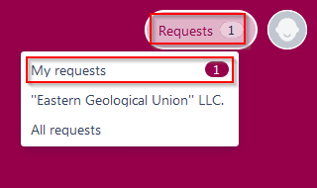

The current status of the ticket in the example is ‘OPEN’. If you click on the reference number or the Summary, the ticket’s own page will be displayed, therefore you can put additional comments, attach or remove files or review the ticket.

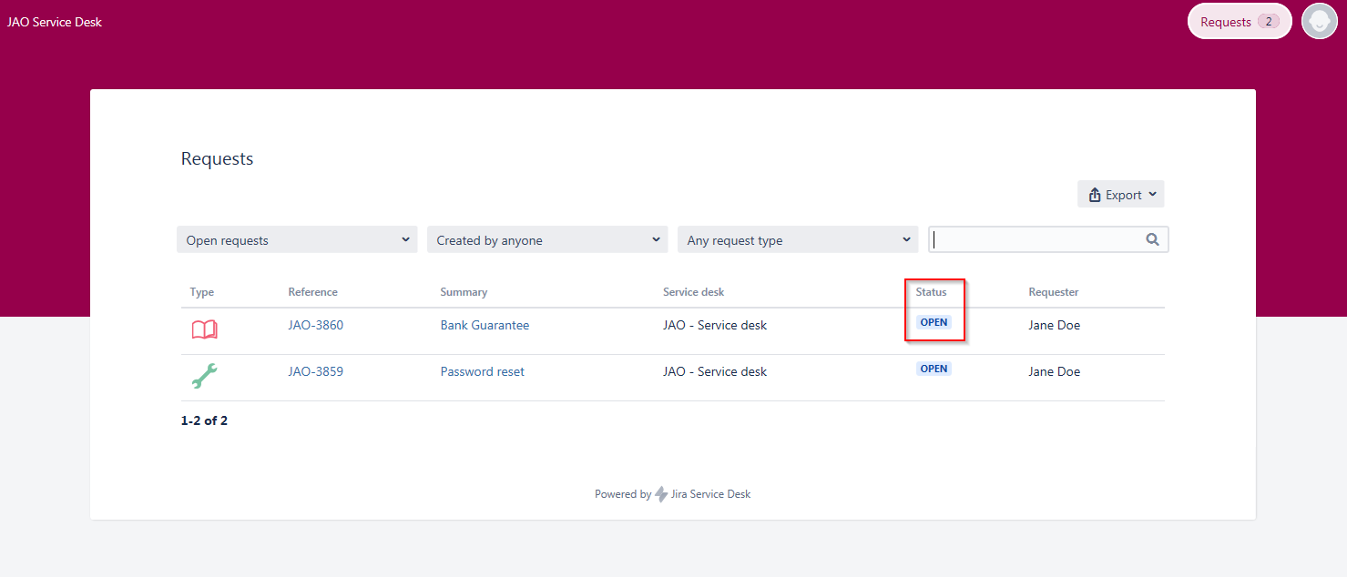

You will be able to see tickets created by you, and also the tickets created by your colleagues (If they selected to share the ticket with the company). You just need to select from the drop down menu option “Created by anyone”.

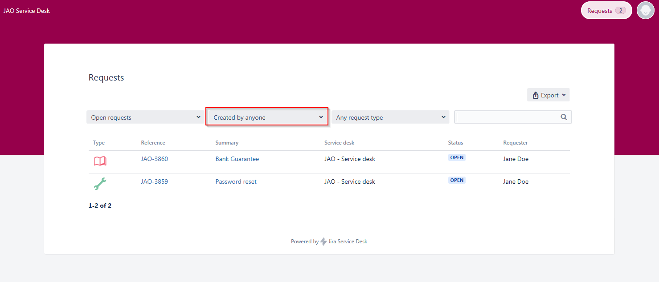

Status changes
As soon as the operators started to work on the ticket, the status will be updated under the aforementioned ‘Request’ menu And on the ticket’s own page:

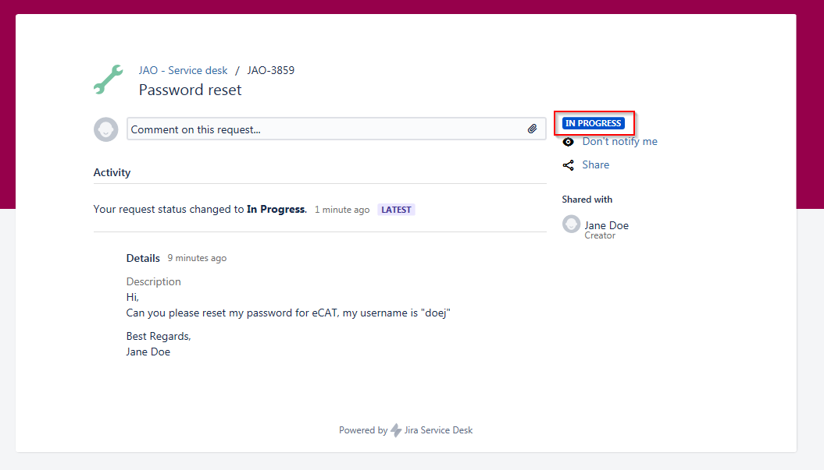

As soon as the ticket has been commented on, you will receive a notification email and the ticket will also be updated:

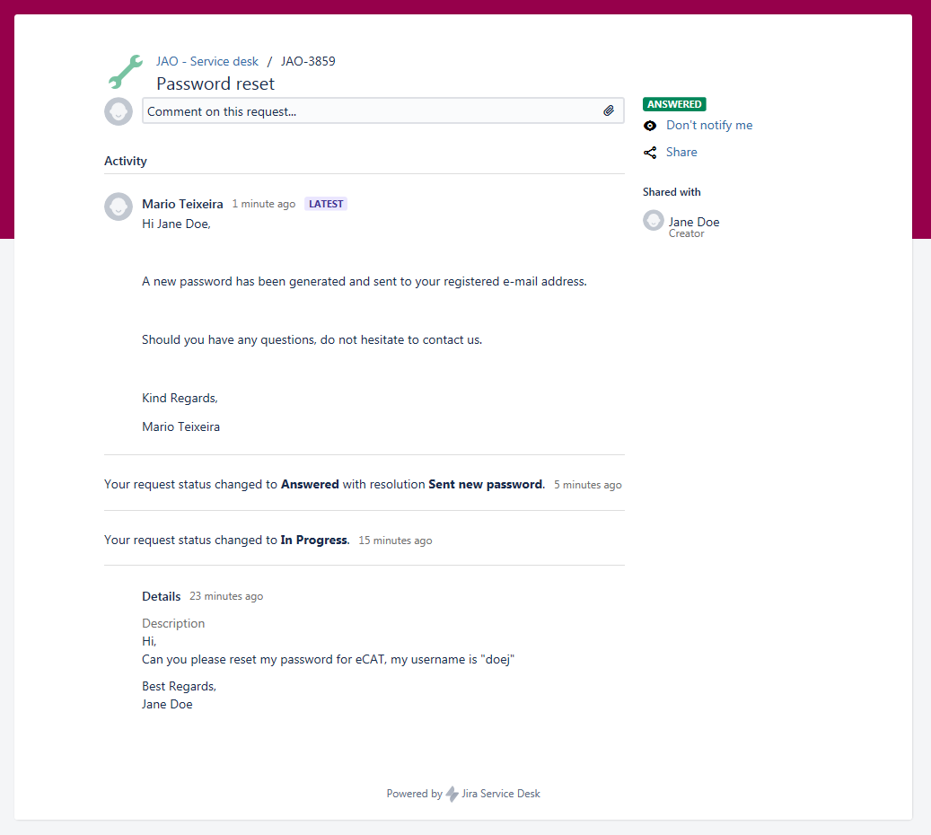

If the issue was handled, the JAO operator will mark the ticket as ‘Answered’ and you will be informed accordingly via
e-mail notification.

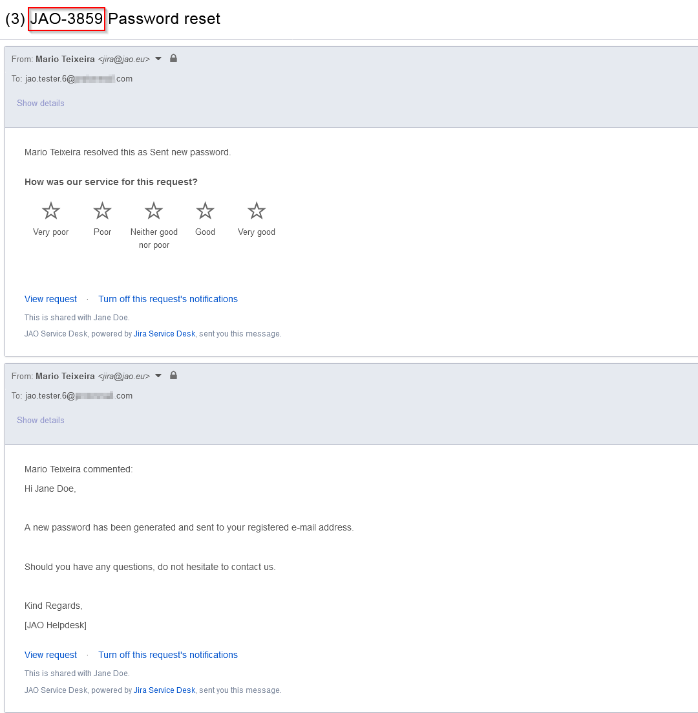

Ticket Follow-up
You will still be able to check your ticket or comment (if needed). Clicking again on the ‘Requests’, make sure, that you are using the right filters, since the ticket was solved/resolved, you need to select ‘Any status’ or ‘Closed requests’. Please also note, that you can see your colleagues’ tickets (if they selected to share the ticket with your company) just change to filter from ‘Created by me’ to ‘Created by anyone’.

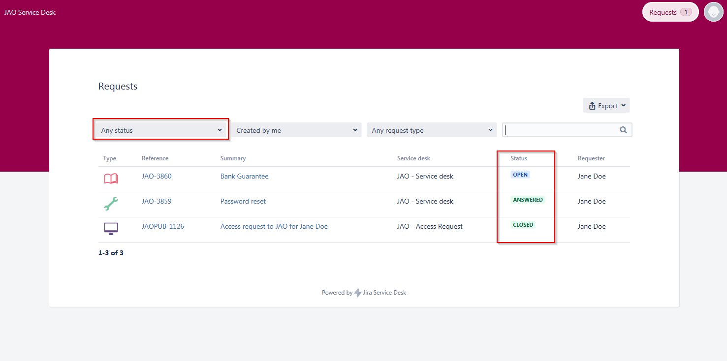

If no further actions are required, the JAO Operator will close the ticket. Then it cannot be commented on anymore, a new ticket has to be opened for handling another issue.

Note: If you refer to a previous ticket with its reference number, the JAO Operator can reopen the ticket if needed.

User Profile
You can edit your user profile, meaning:

- Change your current password
- Change your phone number
- Change your Full Name

Just simply click on the ‘Profile’ menu in the top right corner of your screen.

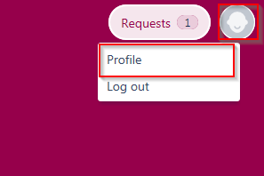

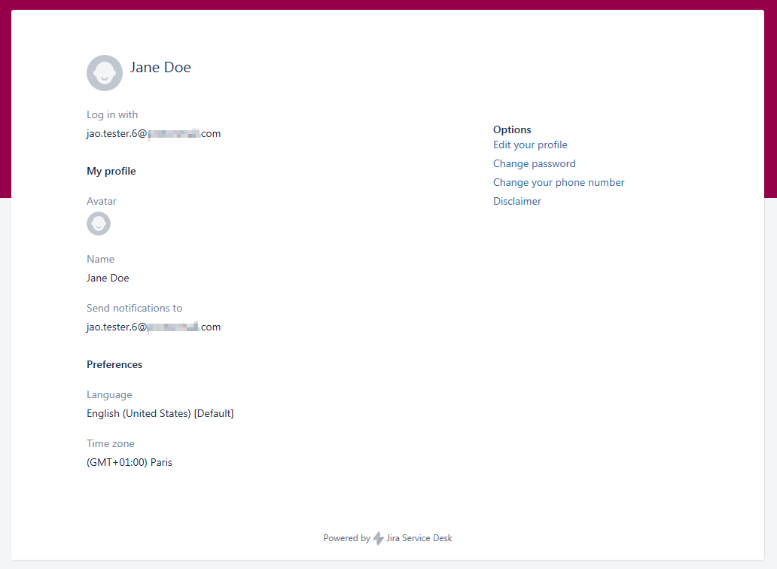

Should you need any further information, feel free to contact us.

Operations Team
JAO S.A.
2 rue de Bitbourg
L-1273 Luxembourg-Hamm
Phone : +352 27 62 38 38

Working Hours
From 08:00 to 17:00 (CET/CEST) on Working Days

