Outcome of the credit limit and bid prioritization requirements survey

Background
On 17th of June 2022 JAO launched a survey on its website in order to collect Market Participants’ ideas on credit limit and bid prioritization requirements.
Market Participants had access to a presentation containing JAO’s proposal and were encouraged to present new ideas in case none of the options presented were preferred by them.
Survey results
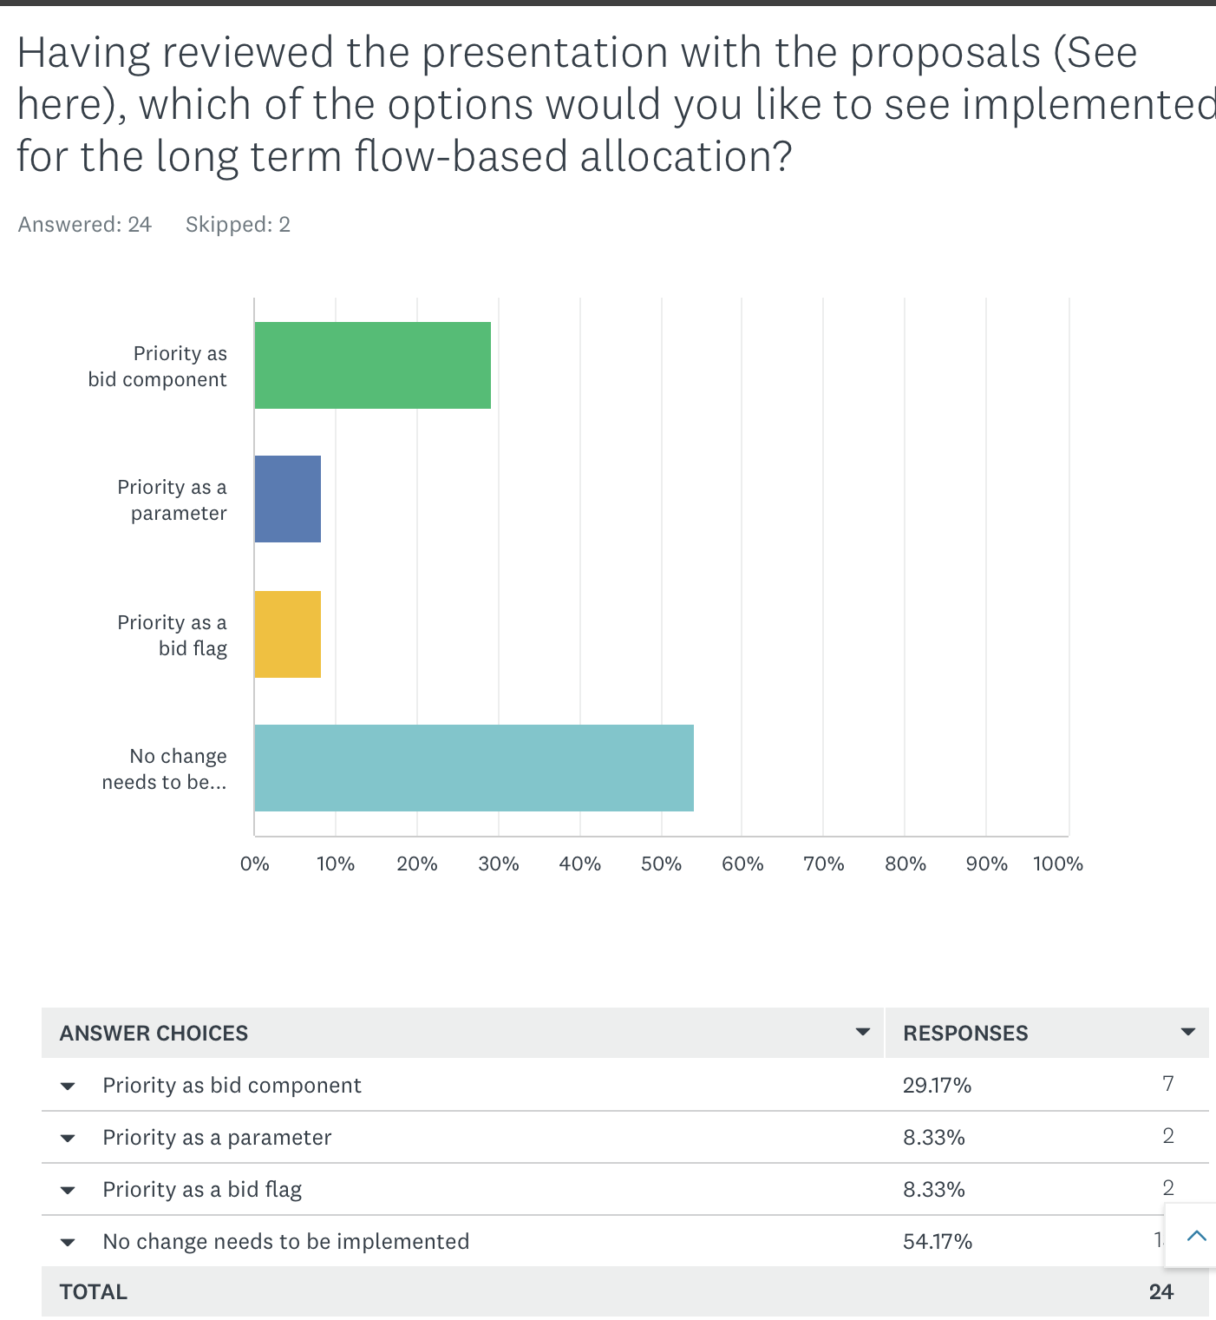

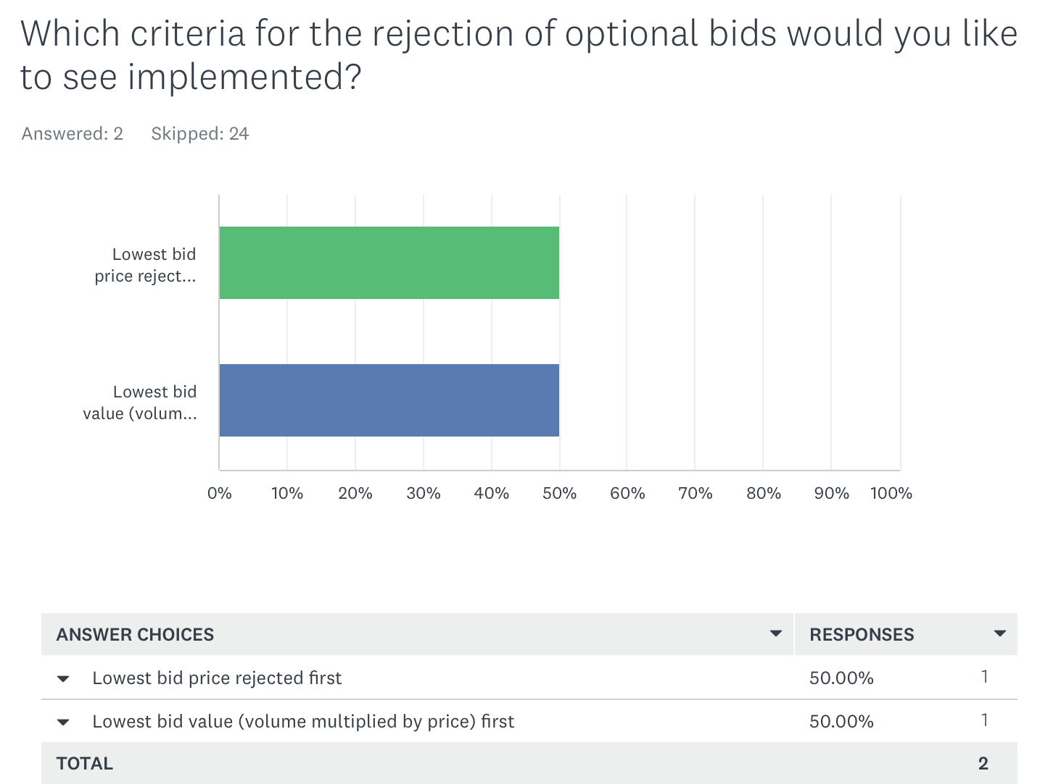

See the comments and suggestions in the table below:
Nr. | Comment
1. | Neither the random nor the prioritized bid rejection criteria are satisfactory.  Bids are submitted because they are the results of a bidding strategy. Rejecting them on a random manner is just ignoring this. Also, asking market participants to prioritize bids would suppose that market participants can prioritize them. A bidding strategy has to be considered as a whole and bids resulting from it cannot be split up in priority groups as the consistency within a bidding exercise would be consequently torn apart.
2. | None of the options proposed.  We would like to raise our strong concerns regarding this consultation. JAO is warning on very serious issues regarding the impact on collateral’s requirements that this centralized FB auction will have. At the light of this identified issue, we call for an updated analysis of the benefits of LTFBA, considering this issue of collateral raised by JAO to assess the impact on the auction results depending on different options.  In terms of content, we consider that none of the options proposed (i.e., priority as bid component, priority as a parameter, priority as a bid flag) is satisfactory as the common concept behind those is not acceptable. New rules of bid rejection that would be detrimental to market participants w.r.t. to the current situation should be avoided. Neither the random nor the prioritized bid rejection criteria are satisfactory. Bids are submitted because they are the results of a bidding strategy. Rejecting them on a random manner is just ignoring this. Also, asking market participants to prioritize bids would suppose that market participants can prioritize them. A bidding strategy has to be considered as a whole and bids resulting from it cannot be split up in priority groups as the consistency within a bidding exercise would be consequently torn apart.  While we acknowledge the issue raised by JAO, we ask alternative solutions other than « bid rejection for credit limit » to be considered, such as different collateral management. Therefore, we call for an urgent meeting with ACER, ENTSO-E and JAO in order to discuss it with market participants.  Also, this is an opportunity to review the way the collaterals are computed by JAO as of today (which would mitigate the impact on the amount of collaterals with one auction). We understand that the amount of collateral is currently estimated depending on a worst-case scenario that could happen in terms of default / credit risk. However, other solutions could be based on the volumes actually involved while using fine-tuned parameters for the JAO collateral computation method.
3. | The European Federation of Energy Traders (EFET) welcomes the opportunity to provide comments to the JAO public survey on credit limit and bid prioritization in the process of designing the future long-term flow-based auction setup in the Core region.  We welcomed that JAO accommodated our request for the deadline postponement because ten days were not enough to engage with market participants. Such a practice for a topic that has such a strong impact on the forward market must be avoided.  However, this issue should have been discussed during the ENTSO-E workshop on LTFBA on 24 May. More importantly, it should have been part of ACER consultation last summer and of ACER assessment before making the decision to go for a central flow-based auction. Moreover, the audience of the consultation’s announcement appeared to be quite narrow as many market participants did not see it, further reducing the initial time to answer.  1. Having reviewed the presentation with the proposals (See here), which of the options would you like to see implemented for the long term flow-based allocation?  We would like to raise our strong concerns regarding this consultation. JAO is warning on very serious issues regarding collateral impact that this FB central auction will have.  In terms of content, we consider that none of the options proposed (i.e., priority as bid component, priority as a parameter, priority as a bid flag) is satisfactory. « Bid rejection for credit limit » should not happen. This would be a clear step back compared to today’s situation where there is no such rejection because the auctions are spread over time (not concomitant).  2. Which criteria for the rejection of optional bids would you like to see implemented?  Neither the random nor the prioritized bid rejection criteria are acceptable. Bids are submitted because they are the results of a bidding strategy. Rejecting them on a random manner is just ignoring this. Also, asking market participants to prioritize bids would suppose that market participants can prioritize them. A bidding strategy on so many borders has to be considered as a whole and bids resulting from it cannot be split up in priority groups as the consistency withing a bidding exercise would be directly torn apart.  3. Do you have any comments or suggestions?  We urge ACER, TSOs and JAO, in cooperation with market participants, to find an alternative solution to this bid rejection principle. Therefore, we call for an urgent meeting with ACER, ENTSO-E and JAO in order to discuss it with market participants.  We recommend an updated analysis of ACER Decision on the additional benefits of LTFBA is needed, considering the recent issue of collateral raised by JAO. There should be a simulation of bid restrictions in order to assess the impact on the auction results.  As a consequence of a negative results, we propose an amendment of the forward CCM methodology and maintain FB CC and remove FB allocation.  Should no solutions of bid restrictions be found than a reconsideration of FB auction becomes necessary so that there are no restrictions for market participants.  Other solutions for collateral management other than bid rejections should be considered.
4. | This issue should have been discussed during the ENTSO-E workshop on LTFBA on 24 May.  More importantly, it should have been part of ACER consultation last summer and of ACER assessment before making the decision to go for a central flow-based auction. Considering this recent issue of collateral raised by JAO, we recommend an updated analysis of ACER Decision on the additional benefits of LTFBA. As a consequence of a negative results, we propose an amendment of the forward CCM methodology and maintain FB CC and remove FB allocation. That being said, alternative solutions other than bid rejections should be considered in priority, such as different collateral management.  For example, a solution could be to reduce the collateral needed for the yearly auctions, currently set at 2 months (out of 12).  It could be considered, for example, to be reduced to 1 month. We call for an urgent meeting with ACER, ENTSO-E and JAO in order to discuss it with market participants.
5. | We urge ACER, TSOs and JAO, in cooperation with market participants, to find an alternative solution to this bid rejection principle. Therefore, we call for an urgent meeting with ACER, ENTSO-E and JAO in order to discuss it with market participants. We recommend an updated analysis of ACER Decision on the additional benefits of LTFBA is needed, considering the recent issue of collateral raised by JAO. There should be a simulation of bid restrictions in order to assess the impact on the auction results.
6. | ……. fully supports the response submitted by the European Federation of Energy Traders (EFET) to the JAO public survey on credit limit and bid prioritization. Conducting this kind of survey does not do justice to the importance of the issue as raised by JAO. Consequently, we would welcome a more broader discussion among TSOs, JAO, ACER and market participants to find alternative solutions to the bid rejection as proposed by JAO.
7. | Preference is for priority as bid component or bid flag. Which auctions have priority changes constantly from month to month but with priority as parameter likely that old values would not be updated.
8. | Yes, stop this. We will never be able to participate in LT auctions anymore if this is implemented.

