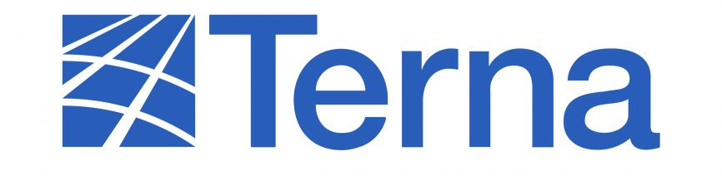


Dear Market Participants,
After the success of the first auction for the 2026 yearly product that was held in September 2025, RTE and TERNA are pleased to announce that the second round for 2026 yearly auction will take place in November/December 2025. Resale will be feasible from yearly-to-yearly auctions.
Please find below the details for the yearly auctions occurring in November/December 2025 (CET timings). The Y BASE 2 product will be offered in the base-flat type, and the Y BASE 3 will be a product with reductions:
Bidding Month | Interconnector | Product | Horizon | Auction Start | Time (of the opening) | Auction End | Time (of the End) | Dispute period
December 2024 | FR-IT | Y BASE 2 | 2026 | 26/11/2025 | 14:40 | 03/12/2024 | 14:40 | 2-2 days
December 2024 | IT-FR | Y BASE 2 | 2026 | 26/11/2025 | 14:40 | 03/12/2024 | 14:40 | 2-2 days
December 2024 | FR-IT | Y BASE 3 | 2026 | 27/11/2025 | 14:30 | 04/12/2024 | 14:30 | 2-2 days
December 2024 | FR-IT | Y BASE 3 | 2026 | 27/11/2025 | 14:30 | 04/12/2024 | 14:30 | 2-2 days

