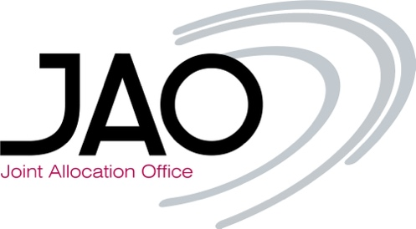
Dear market participants,
We would like to invite you to our next test session for the new Viking Link Interconnector, between Denmark and Great Britain, taking place from the 16th until the 27th of October, 2023.
During these 2 weeks you will be able to participate in dummy auctions to test your bid files, API calls and the integration of eCAT’s output files in your applications.
The scope is the following:
- Daily auctions
- Intraday auctions
- Long term auctions: Yearly, Monthly, Quarterly
To register for the test, please send us the following information to helpdesk@jao.eu (please do not use the JIRA ticketing platform for communication regarding the test):
- Company name
- EIC code
- Username (if you are already registered in eCAT) or your name
- Email address
Registration for this test will close on the 6th of October, 2023.
Should you have any questions or feedback, don’t hesitate to contact us.
Best regards,
Operations team

