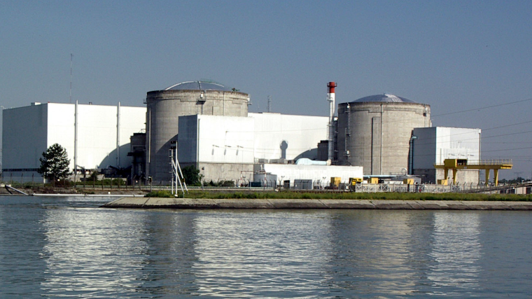

Impact Assessment for the DECOMISSIONING OF NUCLEAR PLANT: FESSENHEIM 1

Paris, 17/02/2020

Context

In the CWE Consultative Group of 30/03/2016 it was agreed that TSOs would perform a Standard Procedure for Assessing the Impact of Changes (SPAIC) for a commonly agreed list of relevant changes, including commissioning/decommissioning of units with a significant impact on cross border capacities.

Introduction

A SPAIC analysis consists of a comparison of flow-based domains for a set of typical “reference” days, commonly predefined by CWE TSOs, in order to estimate the impact of a change in grid topology and/or flow-based parameters.

Following the decision taken by the French government, the French regulator and EDF, the oldest operating nuclear reactors in France, Fessenheim 1 and Fessenheim 2, will be closed permanently in 2020. The decommissioning of Fessenheim 1 will start officially on February 22nd, and on June 30th for Fessenheim 2. These notes and annexes, only refer to the SPAIC for the decommissioning of Fessenheim 1. There is no additional CBCOs, maintenance or any other significant change in the grid topology.

Fessenheim power plant consists of two pressurized water reactors, each of them generating 900MW. The commissioning of these two reactors took place in 1978.

*A second SPAIC will be performed before the decommissioning of Fessenheim 2.*

METHODOLOGY BEHIND THE SPAIC

This SPAIC analysis consists of a comparison of flow-based domains for 12 typical “reference” days commonly defined by CWE TSOs using a clustering algorithm, in order to estimate the impact of a change in the grid topology or flow-based parameters. These 12 reference days are mapped for winter, interseason and summer from 01/10/2018 to 30/09/2019.

An overview of the mapping of the typical days for the market days is given in the file: “Dataset 5 - SPAIC Decomissioning Fessenheim 1 - Typical day description.xlsx”

Published datasets

The following results have been simulated and are published:

1. Flow-based domains and CBCOs for three different scenarios for all reference days:
   1. The historical flow-based domains (“Historical benchmark”)
   2. Updated flow-Based Domains and CBCOs, taking into account significant changes which have been carried out in the CWE area since October 2018 until the SPAIC subject is applied. For all reference days, the following changes were included:
      1. The commissioning of NEMOlink;
      2. The commissioning of COBRAcable;
      3. The grid reinforcement assets in Netherlands;
   3. The new pre-solved flow-based domains and CBCOs calculated with the most probable grid topology taking into account the decommissioning of Fessenheim 1 power plant.
2. The market coupling results for 359 days for all above three scenarios of flow-based domains and CBCOs.

* From the 365 days of the 1-year period, 6 days were not simulated because of the following reasons:
  + 3 days not mapped by the cluster of Reference days (12/02/2019, 24/02/2019, 15/03/2019) – technical issues.
  + 2 days due to clock change (28/10/2019, 31/03/2019).
  + 1 day because of the absence of results in SFT due to the decoupling of EPEX (08/06/2019)

The table below summarizes the standard outputs of a SPAIC analysis that were agreed upon including a reference to the joined datasets indicating where the corresponding information can be found:

|  |  |  |  |
| --- | --- | --- | --- |
| # | Expected output | Description | Dataset |
| 1 | Description change and features of the typical days | A qualitative description of the foreseen change, period and expected high-level impact resulting from this.  A description of the main quantitative features of the 12 typical days | Qualitative description of foreseen change: Cover Note  Description of the typical days: Dataset 5 |
| 2A | Capacity calculation indicators  Dataset *historical benchmark*   * + 24 PTDF matrices + RAM for each typical day and for all fixed labels   + Min/max Net positions   + Volume | This is the dataset that is used as a reference for the change that is subject of the change | * PTDF matrices + RAM: Dataset 1 – Sheet “Historical Benchmark 2A” * Min/Max NP: Dataset 2 – Sheet “Historical Benchmark 2A” * Volume: Dataset 3 |
| 2B | Capacity calculation indicators  Dataset *updated historical benchmark*   * + 24 PTDF matrices + RAM for each typical day and for all fixed labels   + Min/max Net positions   + Volume | This is the dataset that is updated, including all methodological changes that are known at the time of the study | * PTDF matrices + RAM: Dataset 1 – Sheet “Updated Historical Benchmark 2B” * Min/Max NP: Dataset 2 – Sheet “Updated Historical Benchmark 2B” * Volume: Dataset 3 |
| 2C | Capacity calculation indicators  Dataset *including change*   * + 24 PTDF matrices + RAM for each typical day and for all fixed labels   + Min/max Net positions   + Volume | This is the dataset that includes the change that is subject of the impact assessment | * PTDF matrices + RAM: Dataset 1 – Sheet “SPAIC 2C” * Min/Max NP: Dataset 2 – Sheet “SPAIC 2C” * Volume: Dataset 3 |
| 3A | Realized market indicators for the historical dataset | After the capacity calculation is performed, market coupling simulations have been performed to get insight the impact on the following market indicators for the CWE Bidding Zones :   * Net positions (MRC Net Positions and balanced CWE Net Position) * Market Prices * Market Clearing volumes (executed Supply and Demand) * Social Welfare indicators (Consumer Surplus, Producer Surplus, Congestion Income, Total Social Welfare) | All information can be found in Dataset 4. Column A indicates whether the data refers to scenario #3A, 3B, 3C :   * Net positions (“MRC NP, CWE NP, P” sheet) * Market Prices (“MRC NP, CWE NP, P” sheet) * Market Clearing volumes (“Market Volumes” sheet) * Social Welfare indicators (“Social Welfare” sheet) |
| 3B | Market simulation indicators for the updated historical dataset |
| 3C | Market simulation indicators for the dataset including changes |