Explanatory material for the CWE transparency release

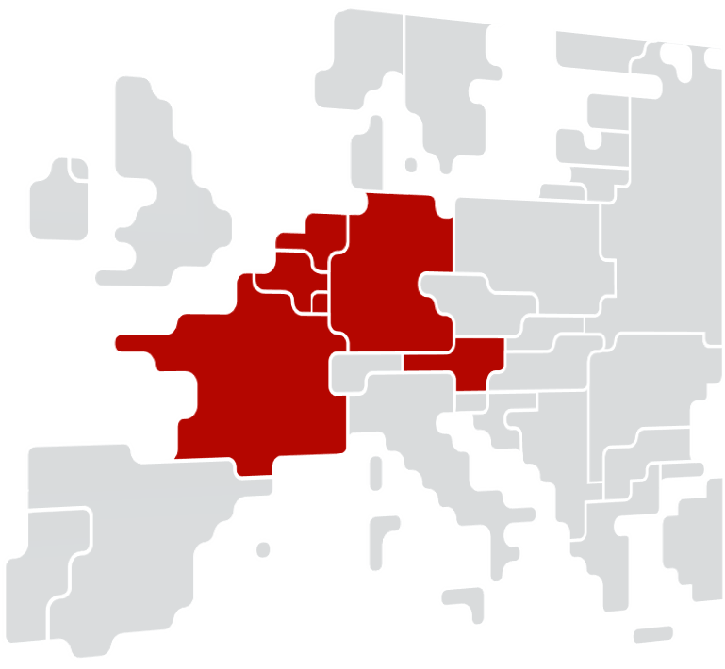
Content
1. Introduction 3
2. Removing anonymization by publishing directly human readable names 3
3. INITIAL FB domain before LTA inclusion and MINRAM (Virgin) 5
4. Final FB domain before LTA inclusion and MinRAM (Virgin) 5
5. Backfill of historical CBs 5

Introduction
Following the interaction as held in the CCG call on 03/09/2019, please be herewith informed on the intended timeline to complete the CWE FBCS transparency release. This document details the changes that can be expected compared to the current data publication as well as an explanation of any mitigations applied at go-live. This document contains additional information about the the following newly provided data to MPs:
- Removing anonymization by publishing directly readable names
- Initial FB domain before LTA inclusion and MinRAM (Virgin)
- Final FB domain before LTA inclusion and MinRAM (Virgin)
- Backfill of historical CBCOs

Removing anonymization by publishing directly human readable names
The below nomenclature will be used to publish human readable names

CB publication name: [hubFrom-hubTo] CB name [Direction] ( + [TSO] if a tie-line)
  - HubFrom, HubTo and TSO can be BE, NL, FR, AT, D2 (Tennet Germany), D4 (TransnetBW), D7 (Amprion), D8 (50Hertz).
  - In order to use a consistent naming for the CB name the following rules are considered: CB name = substation_FROM_name - substation_TO_name elementID
    - substation_FROM_name and substation_TO_name are stable
    - the elementID indicates an element number (e.g. 380.19 for BE elements) or a specific indicator (e.g. “White/Grey/Black/…” for NL elements) to differentiate between parallel elements
    - The CB name always has to include the human readable connected substation names divided by a hyphen.
    - If there is a hyphen in a substation name, no spaces are used.
    - Since element IDs are not always equal over different TSOs, the IDs are harmonized between TSOs to guarantee consistent naming
  - Direction can be DIR or OPP. DIR means that the CB is monitored from firstly mentioned hub/substation to the secondly mentioned hub/substation. OPP inverts the order.
  - TSOs use DIR and OPP to indicate the direction and are stable.

Examples:
- [BE-FR] Achene - Lonny 380.19 [DIR] [BE]
- [BE-BE] Avelgem - Horta 380.101 [DIR]

Tripods publication name: [hubFrom-hubTo] Y - substation (- substation 2 - substation 3) [Direction] ( + [TSO] if a tie-line)
  - Y stands for the node connecting all three branches of the tripod. The firstly mentioned substation after the Y defines the branch of the tripod that is monitored. If it is monitored from the Y-node to the substation the direction is DIR. Otherwise it is OPP.
  - [hubFrom] and [hubTo] refer to the Y-node and the first substation mentioned.
  - TSOs use DIR and OPP to indicate the direction and do not change the order of substations.
  - If there is a hyphen in a substation name, no spaces are used.

Example: [D4-D4] Y - Engstlatt (- Oberjettingen - Pulverdingen) rot [DIR]

PSTs publication name: [hubFrom-hubTo] PST name [Direction] ( + [TSO] if a tie-line)
  - There was no rule defined how the direction of a PST is chosen
  - If there is a hyphen in a substation name, no spaces are used.

Outage publication name: The naming of the outages is harmonized among the different TSOs and is based on the nomenclature of CBs. No direction and TSO is indicated for COs.
Temporary limit parameter
  - If the TSO is using temporary limit leading to different Fmax for the same CNE of the same hour, the timing will be included in the CNE naming.
  - Currently used by RTE.
Example:
[D7-FR] Ensdorf - Vigy 2 [DIR] [FR] - 1'

  - [D7-FR]: Control area in which the CNEC is located
  - Ensdorf - Vigy 2: CNE name
  - [DIR]: Direction of the CNE
    - [DIR]: Current order from the CNE name (here from Ensdorf to Vigy)
    - [OPP]: Opposite order from the CNE name (here from Vigy to Ensdorf)
  - [FR]: TSO monitoring the line only applicable for cross-border lines.
  - – 1’: Temporary limit (leading to different FMax)

Please note that there are some minor issues that will somewhat deviate from the nomenclature.
- Elia will not be able to indicate the full name of a line for contingencies but only the substations (i.e. the element ID will be missing) until their tool is adapted end 2019/beginning 2020 (of which MPs will be informed via a market message). This issue is mitigated by the fact that the EIC code provide the full information.
- Elia will only use the Direction [DIR] until their tool is adapted, with the same timing as indicated above.
- hubFrom-hubTo may be inconsistent for the CNECs provided by Elia until their tool is adapted, with the same timing as indicated above.
- For RTE, Direction [DIR] and TSO monitoring the line will be included in the contingency name as well.

This nomenclature ensures that MPs can read the hyphen [-] and harmonized the FROM-TO naming. The introduction of new elements will be announced on the JAO message board, together with their human readable name. The updated nomenclature will also be included in the publication handbook, to be provided by the go-live of the transparency release.

As basis for the backfill of historical CBs (see details in section 5), TSOs will publish a translation table with the fixed ID , human readable name and EIC at the time of go-live of the transparency release on 01/10.

INITIAL FB domain before LTA inclusion and MINRAM (Virgin)
Initial FB domain before LTA inclusion and minRAM (Virgin) will be published in the JAO Utility Tool. The domain will be published at 02:30 AM, D-1.

Final FB domain before LTA inclusion and MinRAM (Virgin)
Final FB domain before LTA inclusion and minRAM (Virgin) will be published in the JAO Utility Tool. The domain will be published at 10:30 AM, D-1.

Backfill of historical CBs
Following the alignment in the CCG call of 03/09/2019, the backfill will be launched after the CCG call in November. This gives MPs the chance to prepare their local tooling based on the translation table and ask questions for clarification, so that the transition will be smooth.

Once confirmed in December, the backfill will start with the last day before the transparency release and work back to the start of FBMC in May 2015. The results will be visible in the JAO Utility Tool. The current published names will gradually be replaced by the harmonized human readable names.

