Bidding – How-to

# Intent and Purpose

This document is designed to give the best steps to Bid on an Open Auction without unexpected behaviour.

# Steps

1 – Connect to Participant UI

2 – Choose Auction Menu

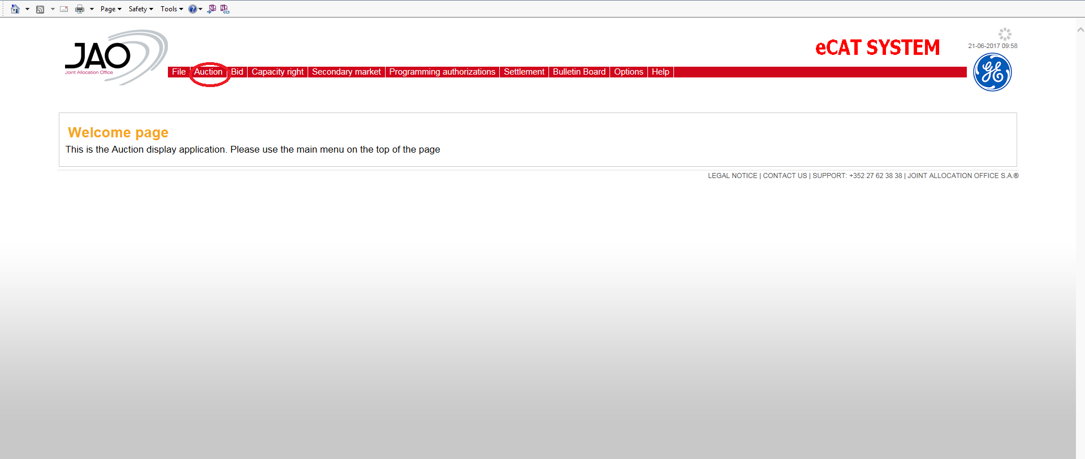

3 – Choose New/Edit Bids link on the Auction you want to Bid:

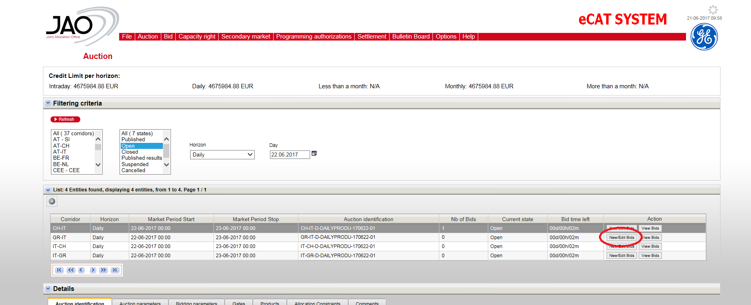

4 – Bidding Matrix appears and you can place your Bids as usual

